VMware Horizon VDI Deployment Guide

**Document Status:** FirstFinal Draft

**Created On:** September 12, 2024

**Last Updated:** September 13, 2024

**Contact:**  ITG Technical Writers, IT Infrastructure Team, Richard Cheng

Contents

1 Purpose 2

2 Scope 2

3 Audience 2

4 Horizon Connection Server Installation 2

4.1 Creating Desktop Pools 18

5 Dynamic Environment Manager Deployment 24

5.1 DEM Console Installation 26

5.2 Configuring the DEM 30

5.3 DEM Licensing 33

6 App Volume Manager Installation 34

6.1 License Installation 41

7 Abbreviations/Acronyms 49

8 Revisions 50

9 Document History 50

10 Document Control Log 50

# Purpose

This document provides detailed instructions and best practices for deploying VMware Horizon components in a VDI environment. It helps G+T IT professionals and administrators understand how to set up, configure, and manage VMware Horizon to efficiently and securely deliver virtual desktops and applications to end users.

# Scope

The document covers the following areas under the control of G+T’s systems, application framework, and administration:

* Horizon Connection Server Installation.
* Dynamic Environment Manager Deployment.
* App Volume Server Installation.

# Audience

This document benefits the infrastructure team.

# Horizon Connection Server Installation

Follow these instructions to install the Horizon Connection Server on various sites:

**Step 1:** Download the latest setup file from the VMware site and run the horizon connection server exe file. Click **Next**:

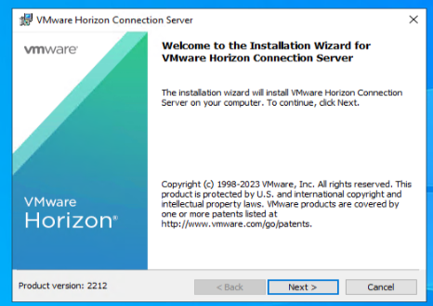

**Step 2:** Selecting the appropriate server:

* Select **Horizon Standard Server** if you do it for the first time on the primary site.

(Or)

* Select **Horizon Replica Server** when reinstalling the secondary site.

Check the **Install HTML Access** box and select **IPv4**. Click **Next**:

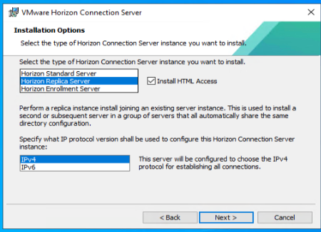

**Step 3:** Enter the horizon connection server (FQDN) and click **Next**:

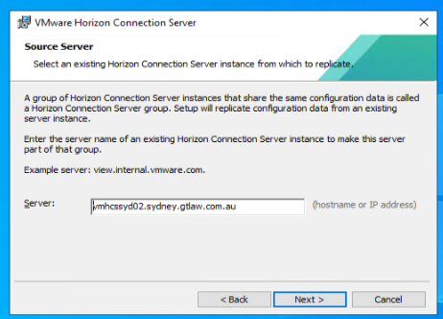

**Step 4:** Select **Configure Windows Firewall automatically**, and click **Next**:

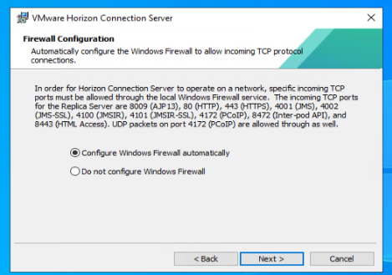

**Step5:** Click **Install** and wait for the installation:

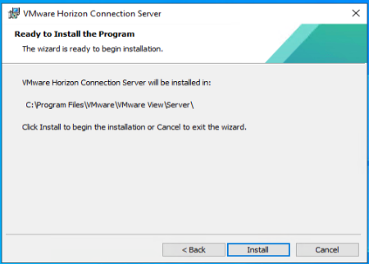

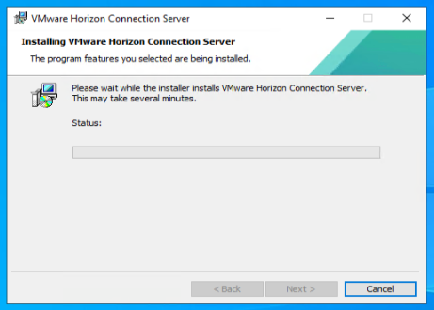

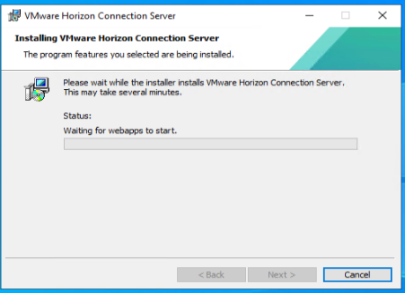

**Step 6:** After installation, click **Finish**:

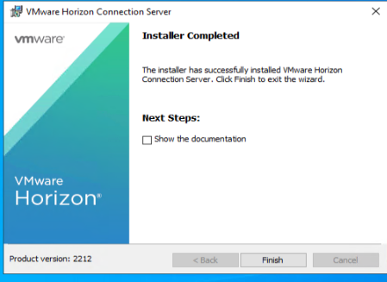

The Horizon configuration begins. You can start with user, role, and permission settings.

**Step 7:** Open Horizon Admin Console, and navigate to **Settings > Administrators > Administrators and Groups > Add Permissions**:

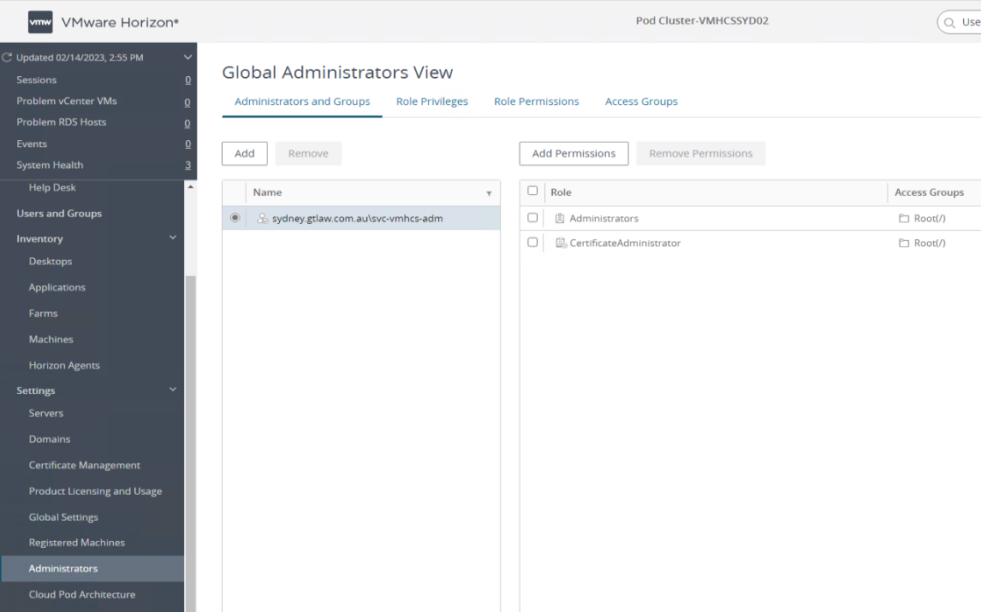

**Step 8:** Click **Add**:

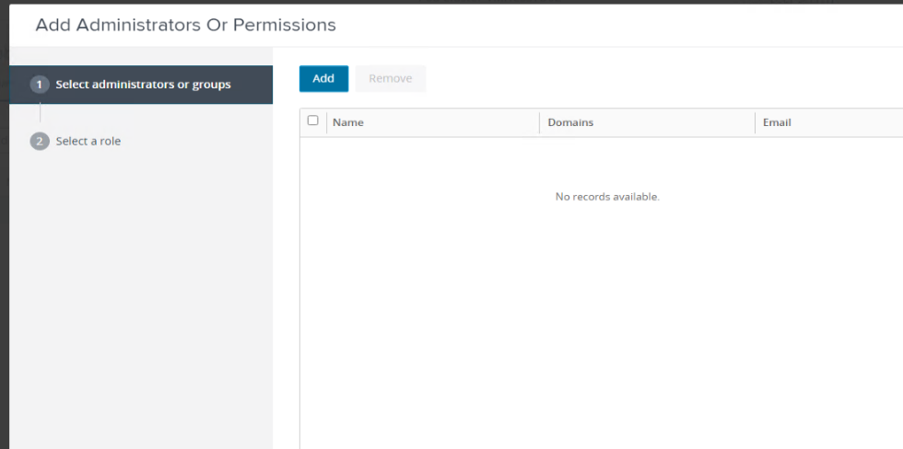

**Step 9:** Search for the security group and select the group. Click **OK** to add the permissions:

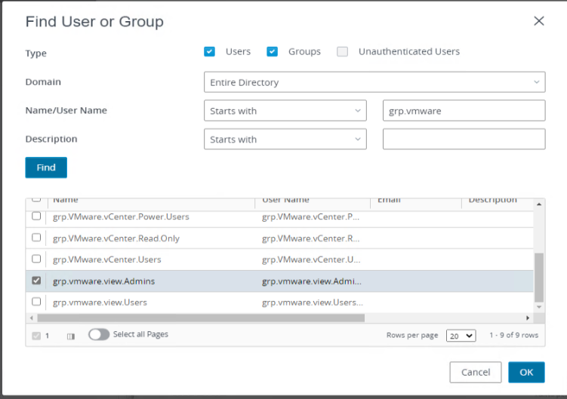

**Step 10:** Add vCenter server by navigating to **Settings > Servers > vCenter Servers**, and click **Add**:

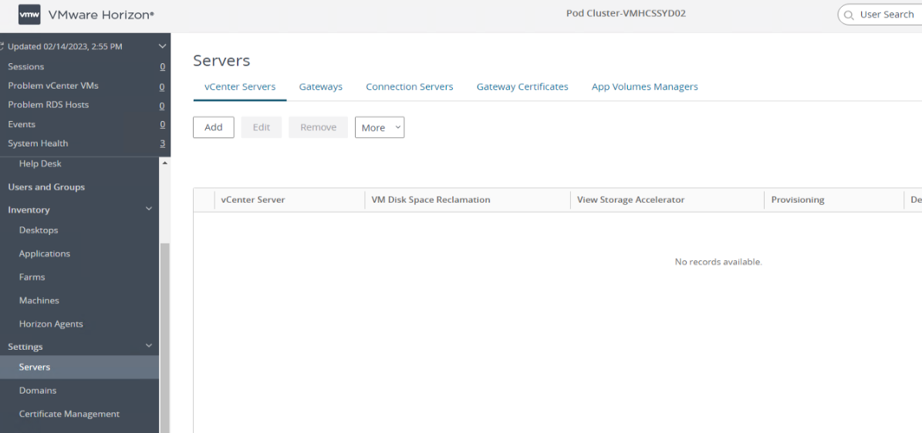

**Step 11:** Complete the following:

1. Enter all the details of vCenter, like FQDN, username (service account), password, description, and port, and click Next under vCenter Information:

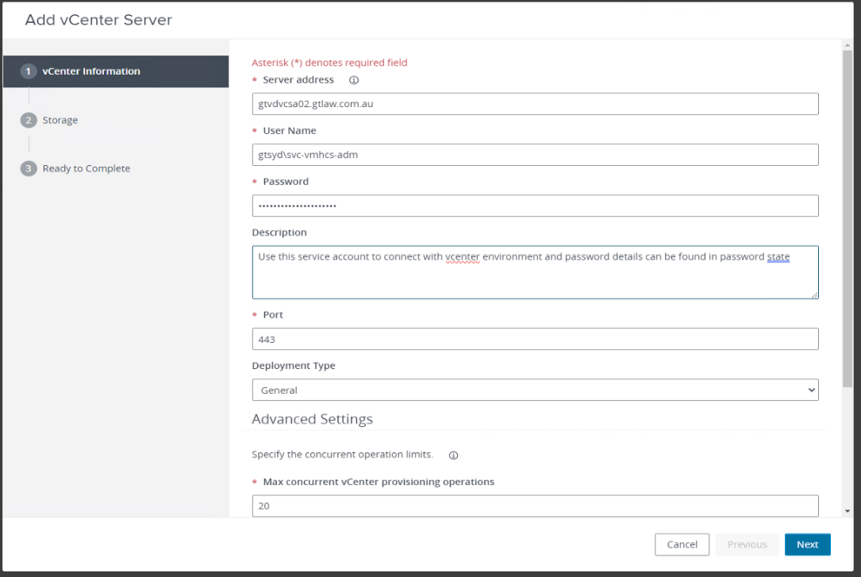

1. Make sure the storage settings are correct and select Datastore (vAN). Click Next:

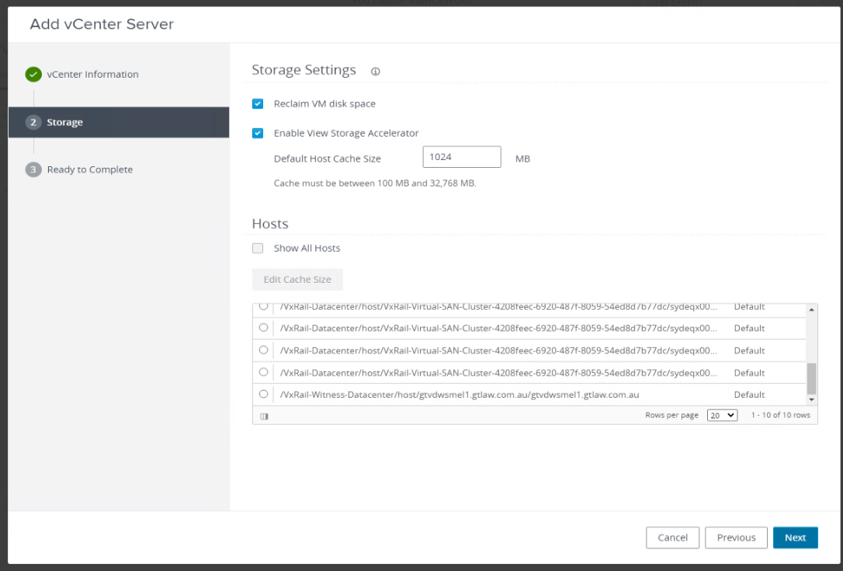

1. Re-check all the details and click **Submit**:

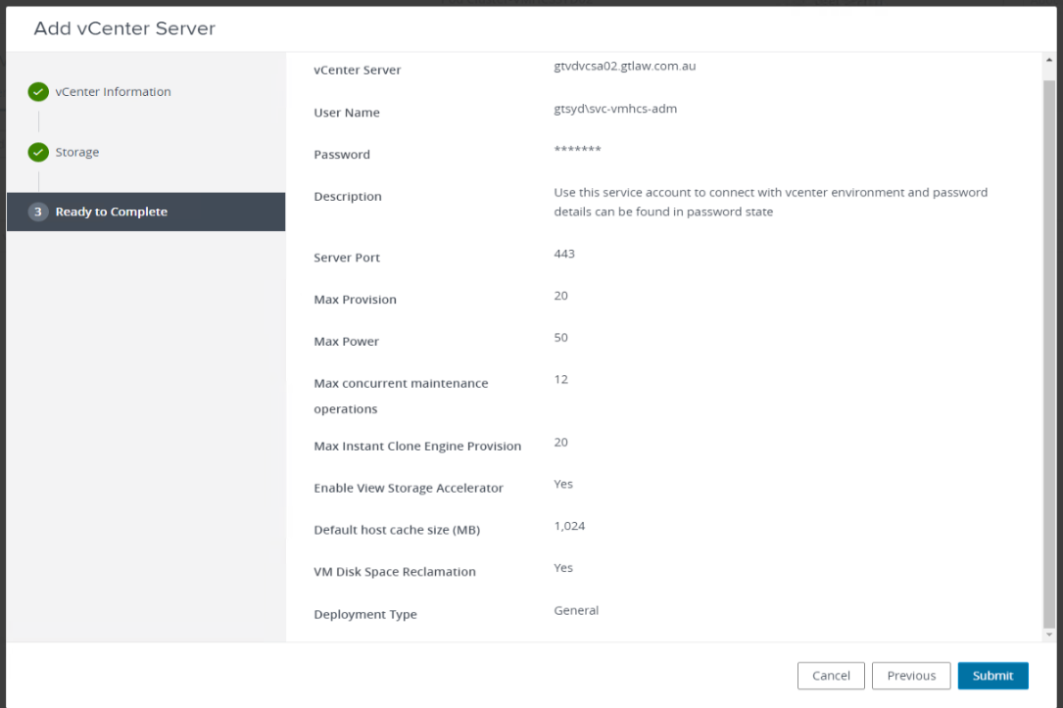

Now, you can see the vCenter server on the home page:

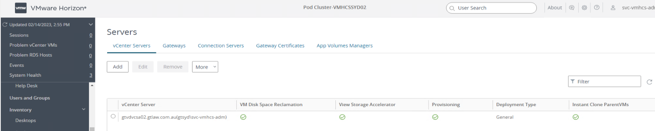

**Step 12:** Now, navigate to the Domains tab and click **Add** to configure the domain into Horizon:

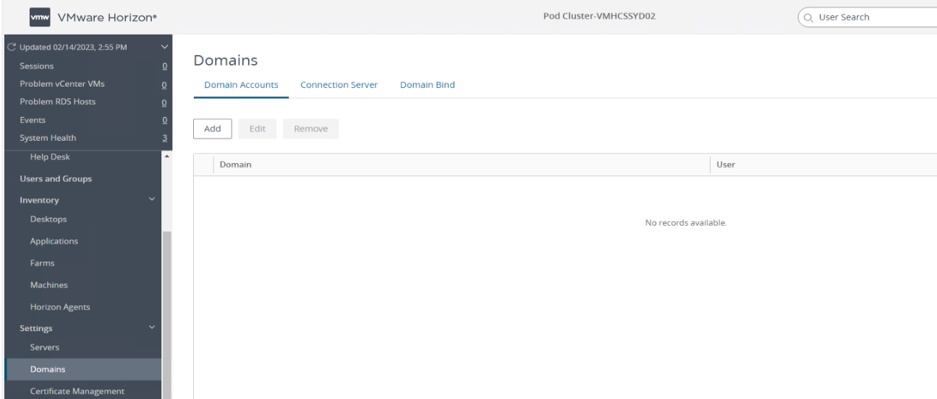

**Step 13:** Search and select the server:

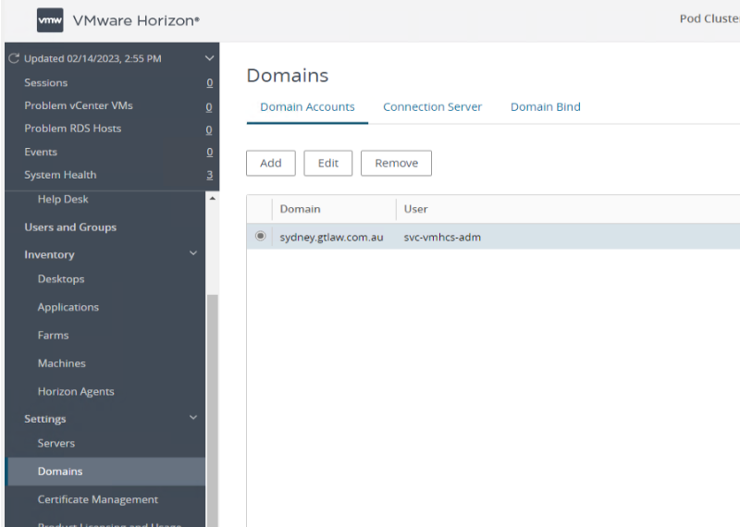

These are the standard Global Settings, which we configured in our Horizon environment:

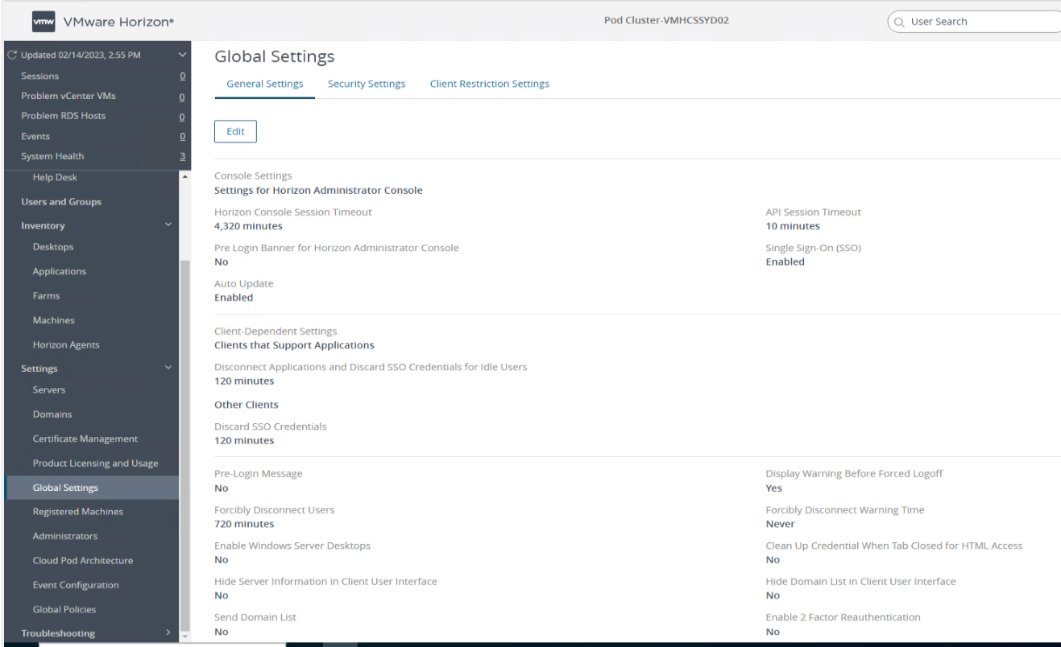

**Step 14:** Create the MS SQL DB with AG on SQL Server or SQL Cluster.

**Step 15:** Right-click the database and select **New Database**:

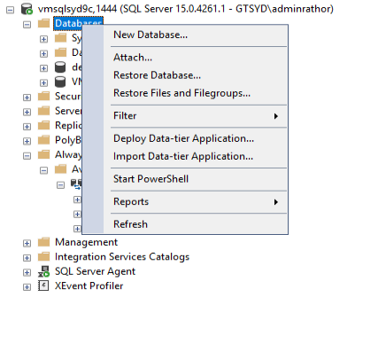

**Step 16:** Perform a complete backup on the database:

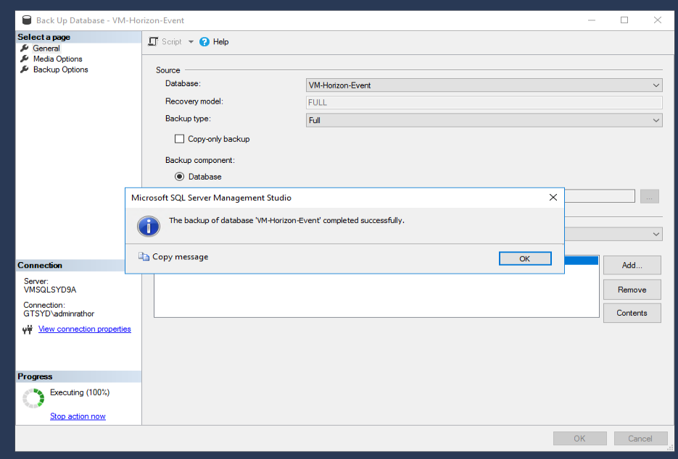

**Step 17:** Add Database to availability group:

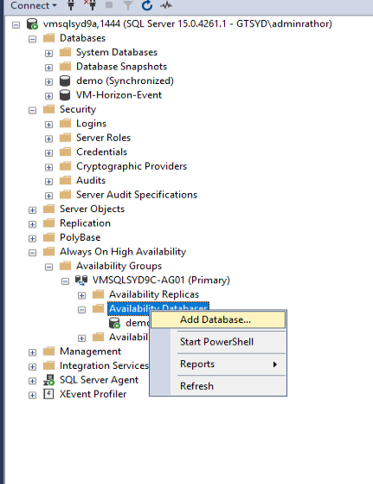

**Step 18:** Select the Database and click **Next**:

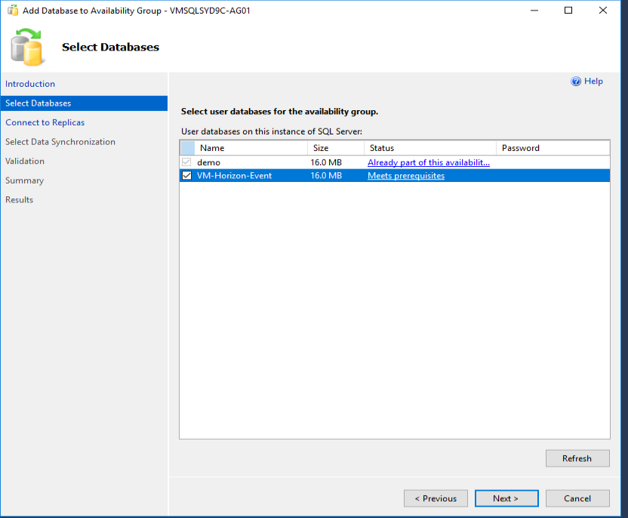

**Step 19:** Connect to Existing Secondary Replicas:

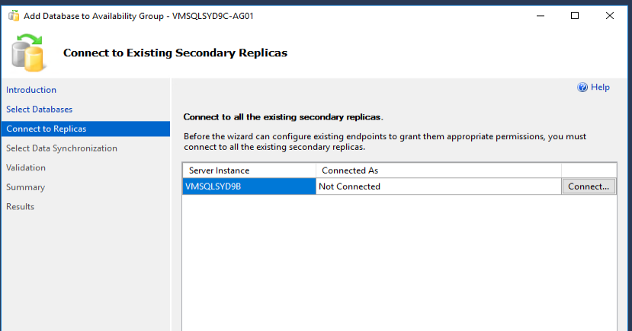

**Step 20:** Click **Connect**:

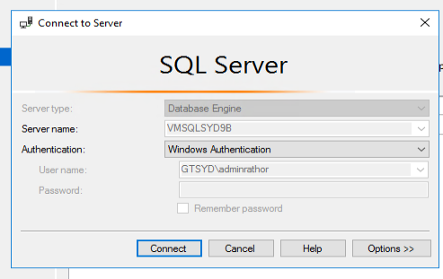

**Step 21:** Setup event DB on the horizon console page, fill in all the details as shown below, and click **OK**:

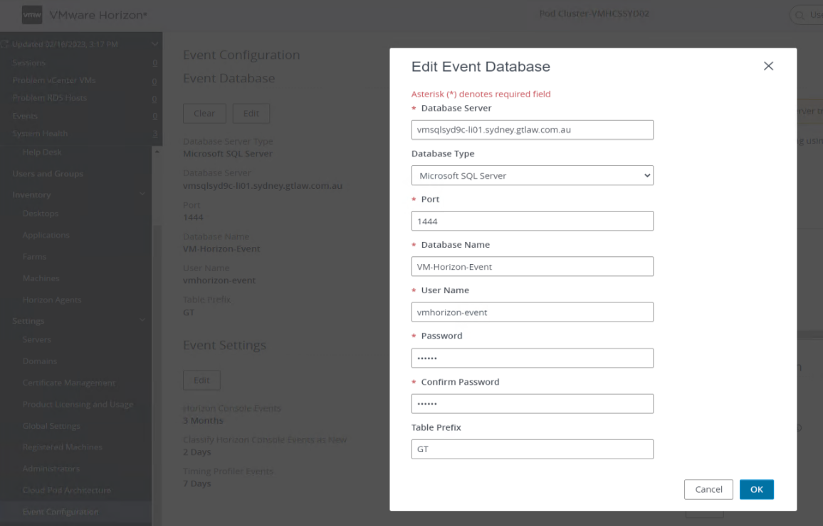

***Please Note:***Horizon DB doesn’t support domain service accounts; you must create a local SQL account to establish it.

**Step 22:** You need to do a few more settings, as per the below screenshots:

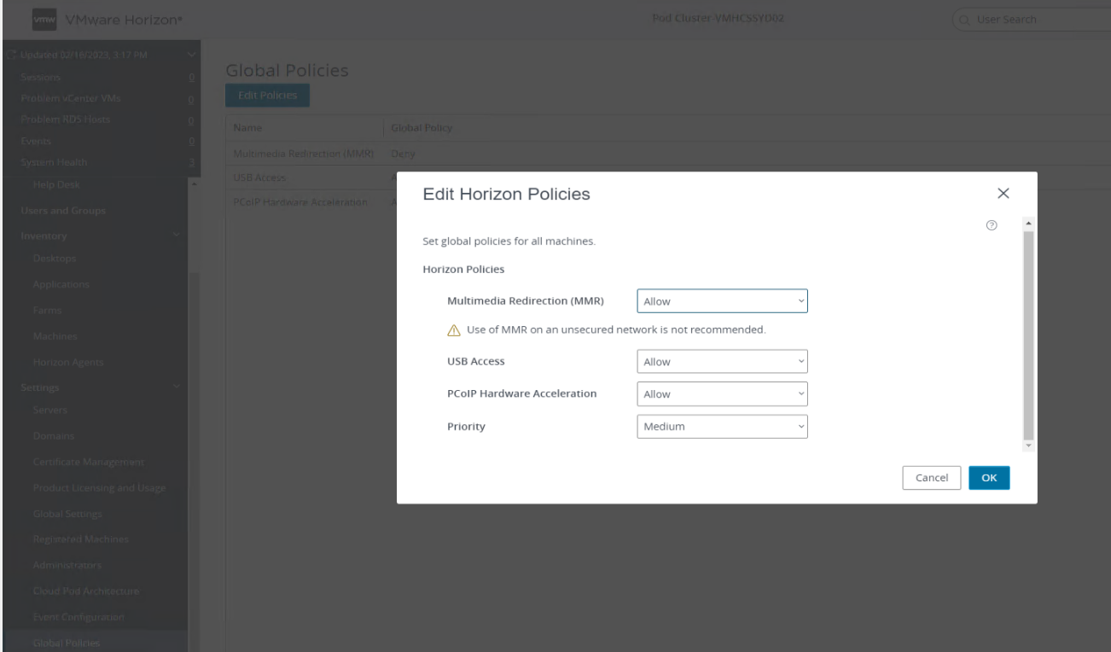

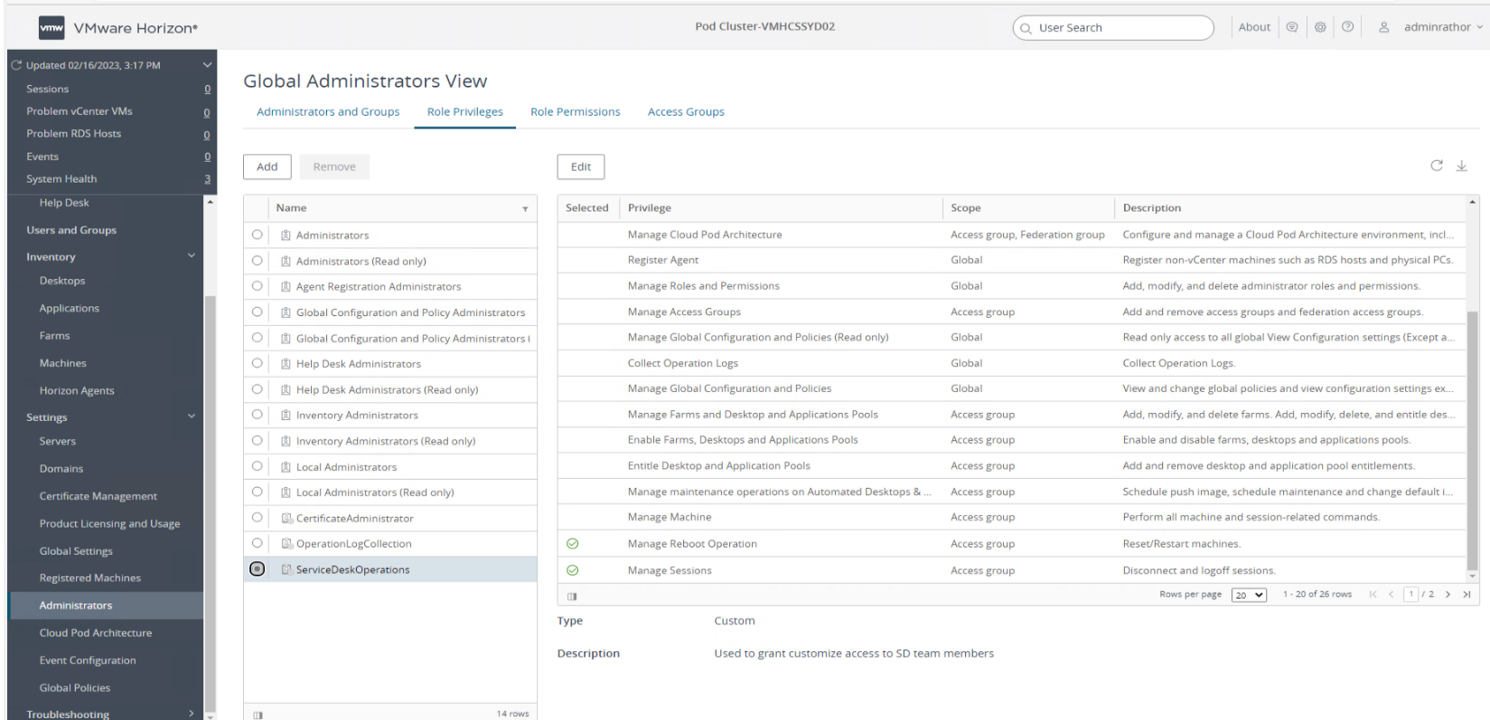

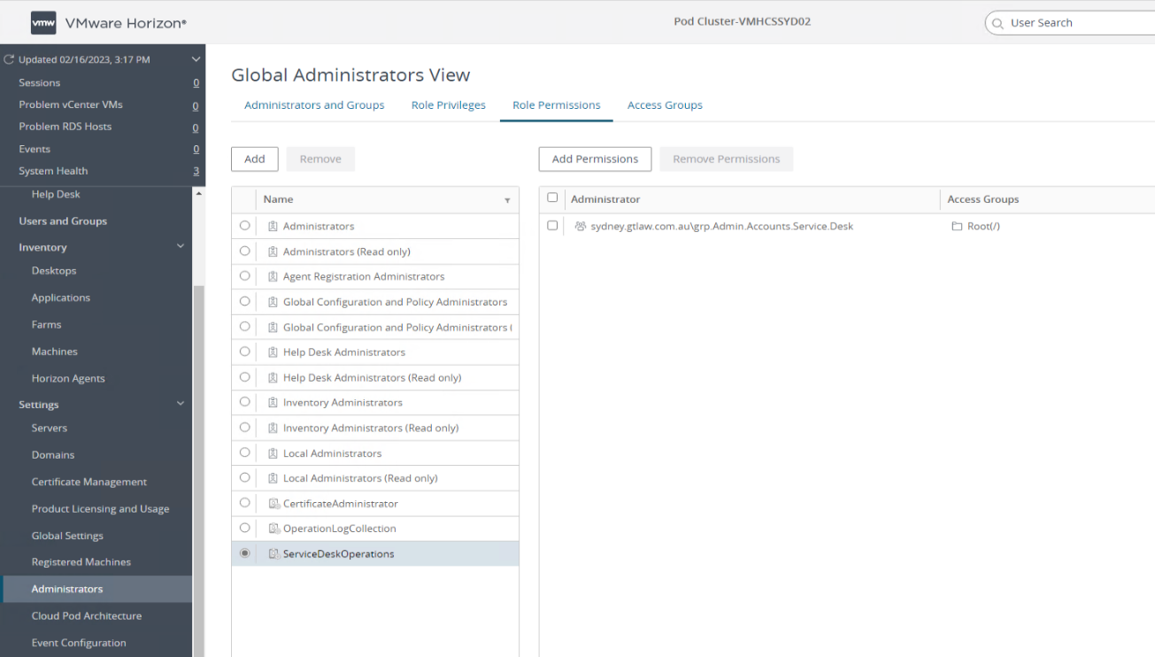

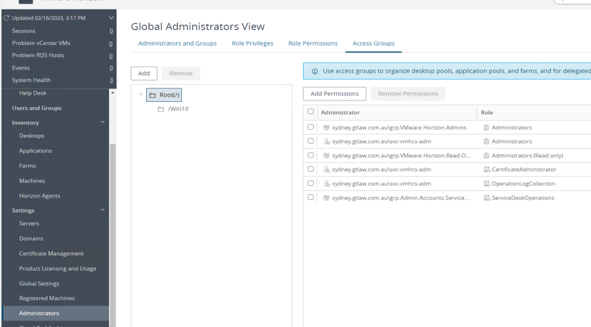

**Step 23:** Next, install the Horizon certificate to ensure it functions with a trusted secure certificate. To do this, log in to the Horizon server, open MMC with admin privileges, go to **File > Add/Remove Snap-ins** **>** select Certificates using the computer account, and add it to the **MMC console**:

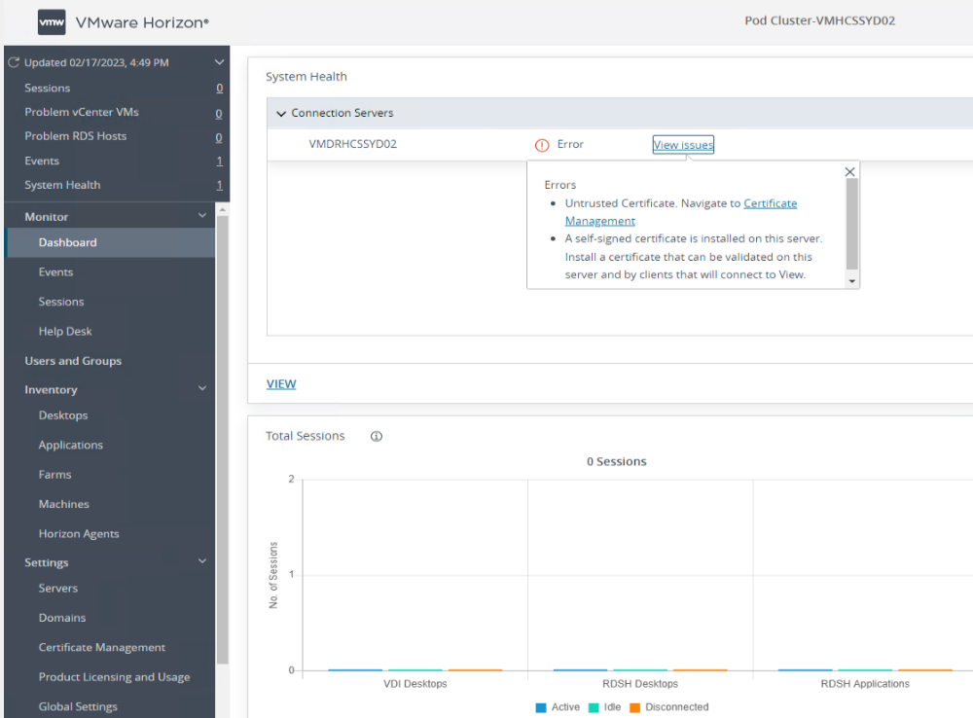

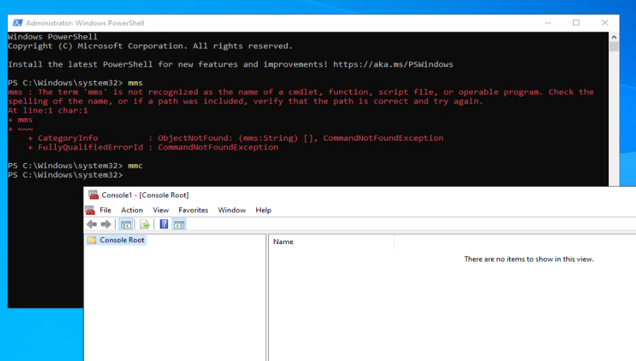

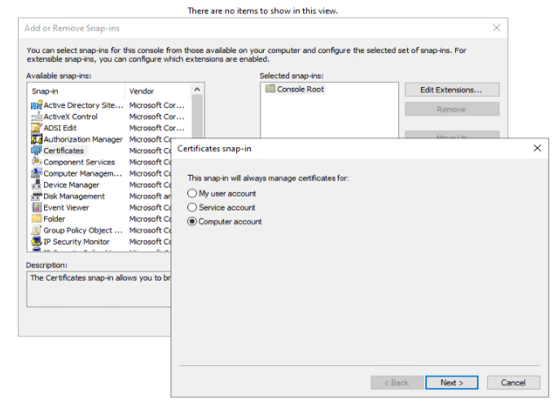

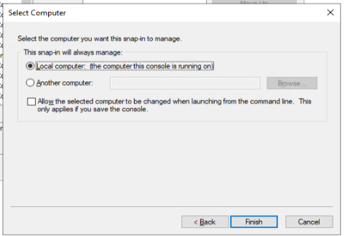

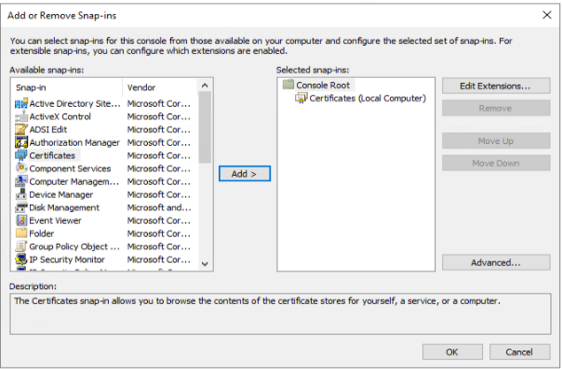

**Step 24:** Now, navigate to **Certificates > Personal > Certificates** and right-click on the right side, click **All Tasks**, then select **Import** (it supports only PFX files):

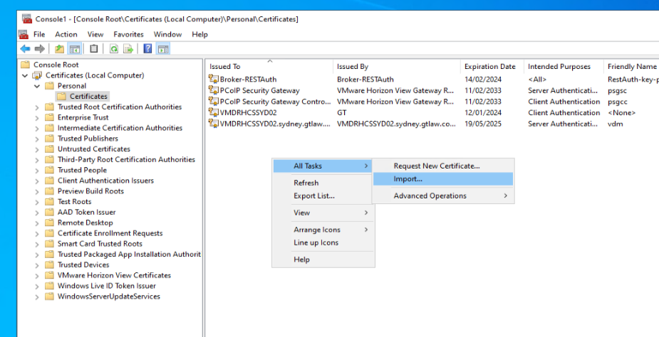

**Step 25:** Select the store location as a **Local Machine**, then click **Next**, and select and open the file from your local folder:

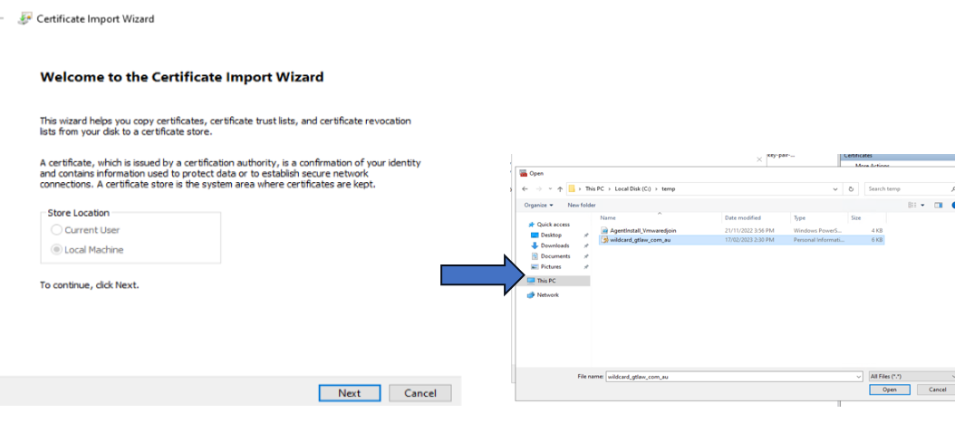

**Step 26:** Browse the file, click **Next**, and enter the password, then click **Next**:

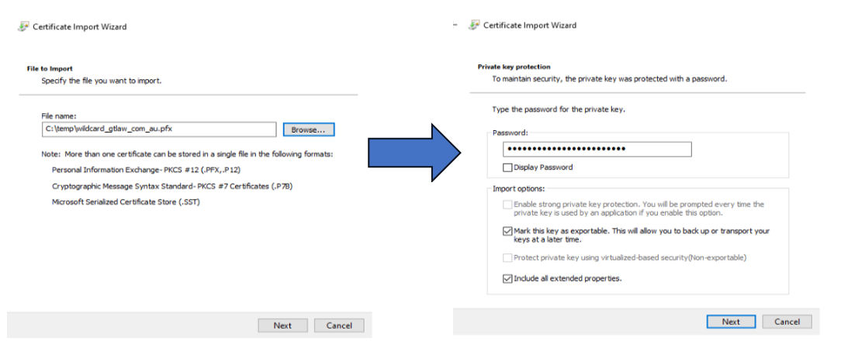

**Step 27:** Select **Place all certificates in the following store**, and click **Finish**:

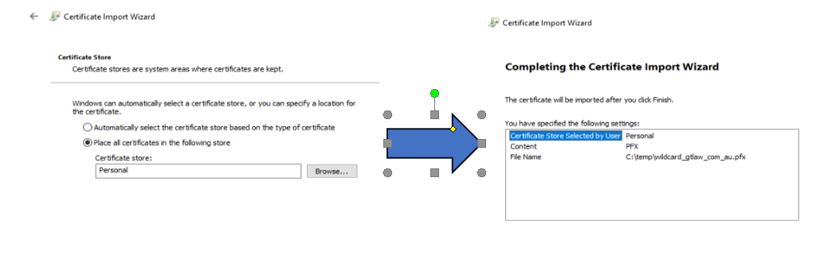

You will get the successful message:

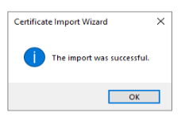

**Step 28:** Now, locate the existing certificate (FQDN server) and open its properties, then rename the friendly name as **old-vdm**:

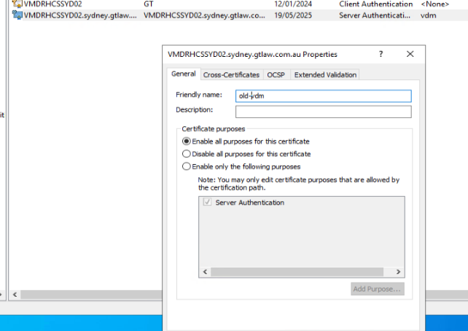

**Step 29:** Now, locate the wildcard new certificate, which was imported, and open its properties, then rename the friendly name as vdm:

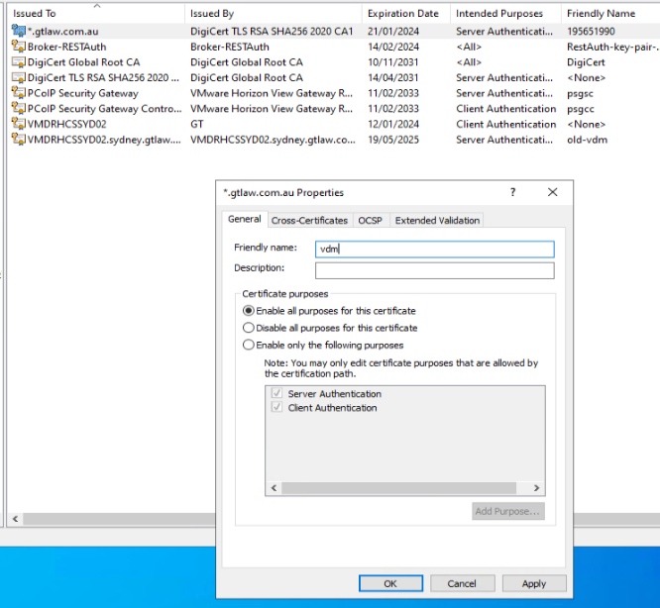

**Step 30:** Restart the VMware Horizon connection server:

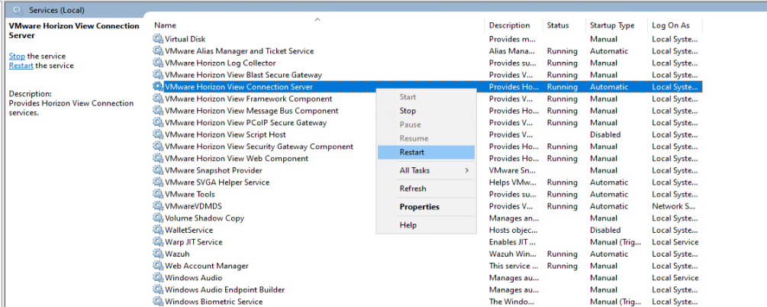

After restart, you will see the home page of Dashboard:

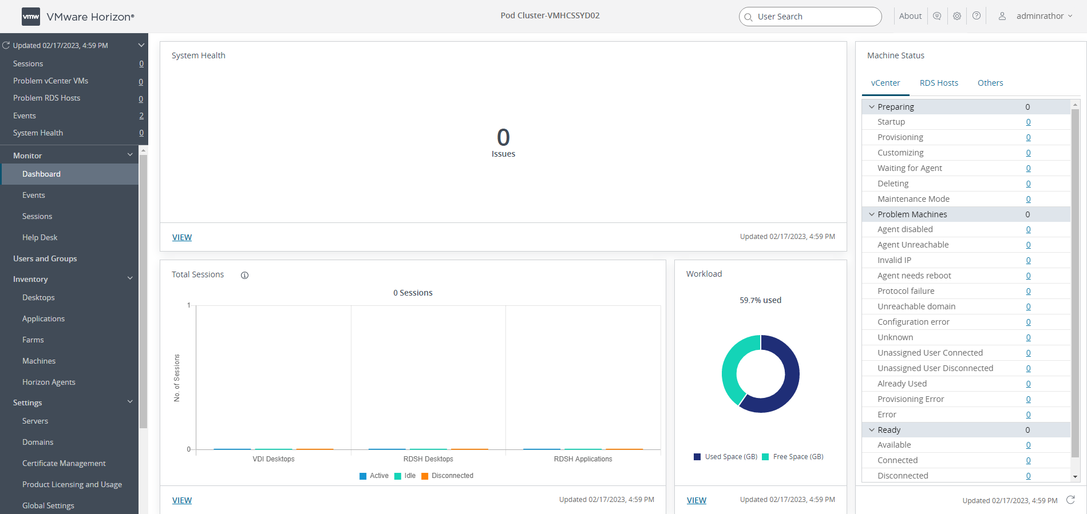

## Creating Desktop Pools

It's time to create desktop pools so users can assign and use virtual desktop infrastructure (VDI). Follow these instructions to create the Desktop pools:

**Step 1:** Navigate to the Desktop section at the left side of the Horizon admin page and click **Add** under Desktop Pools:

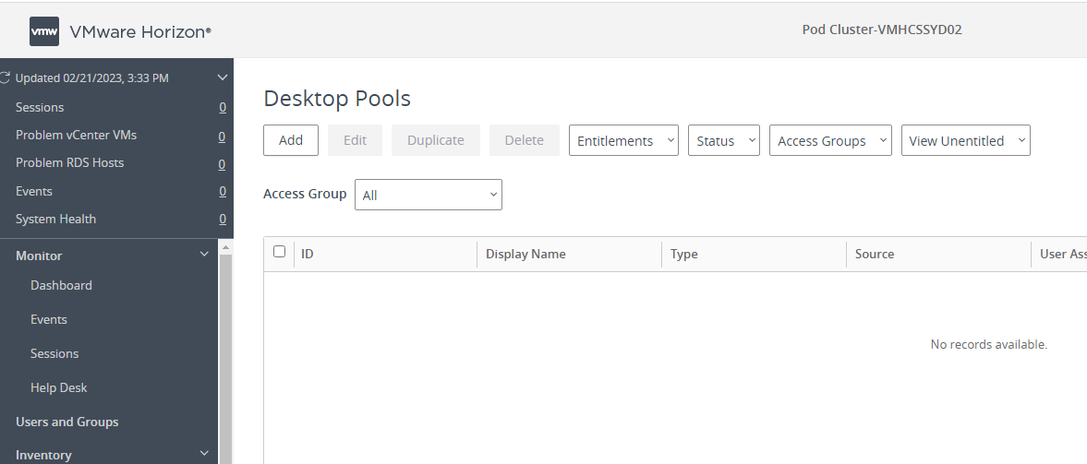

**Step 2:** Select **Automated Desktop Pool**, and click **Next**:

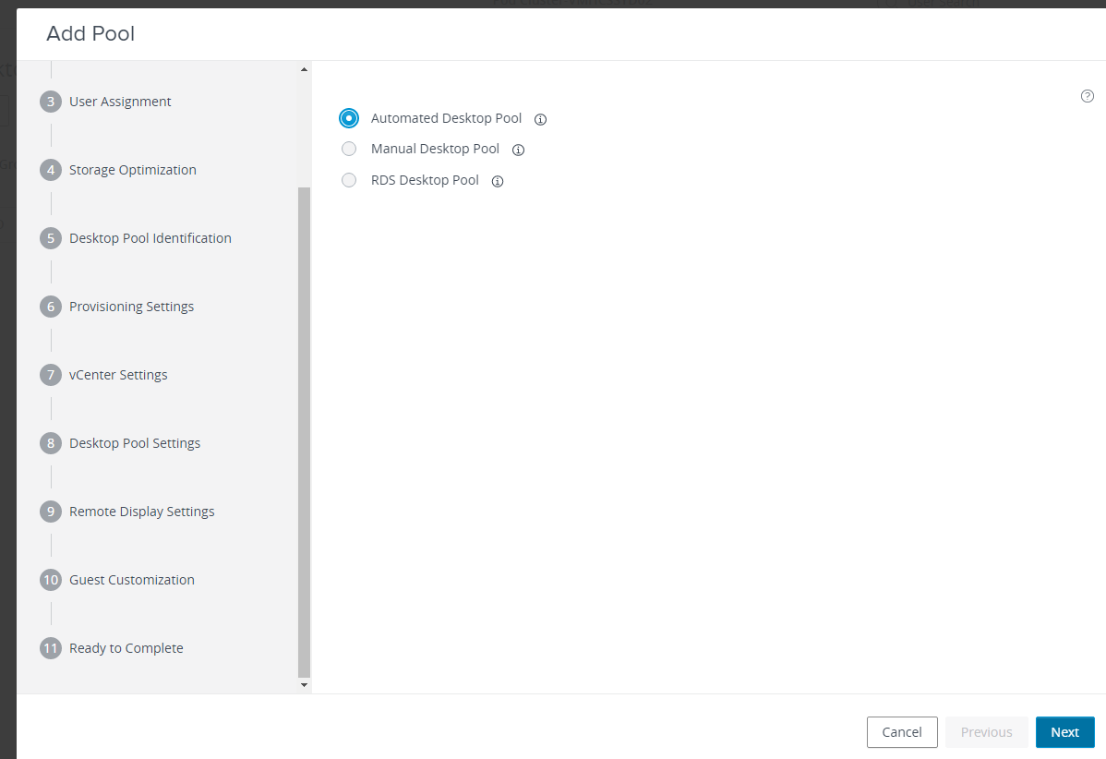

**Step 3:** Select **Instant Clone**, then select **gtvdvcsa02.gtlaw.com.au**, and click **Next**:

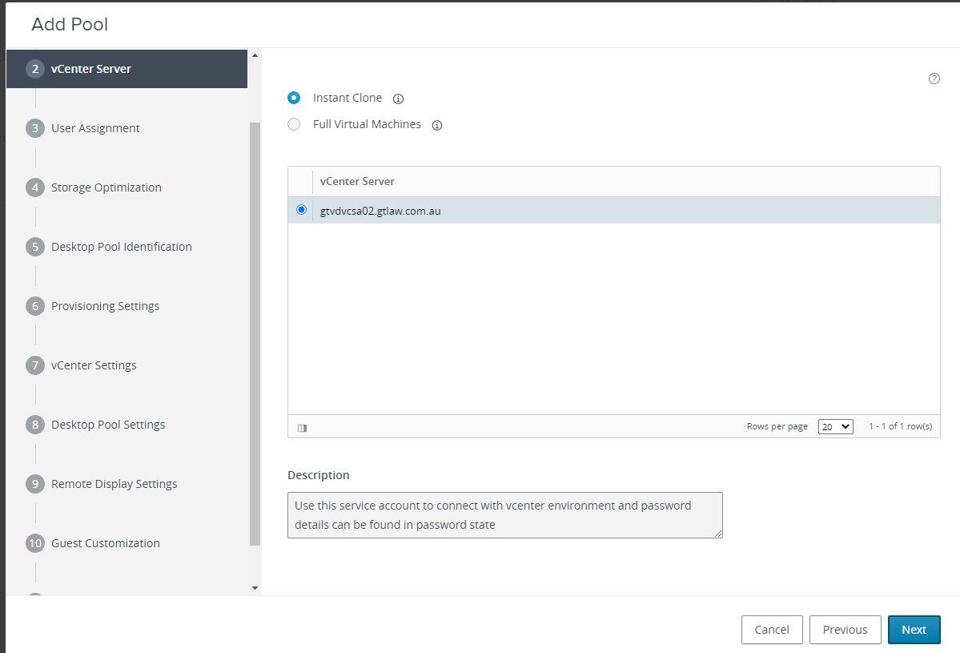

**Step 4:** Select **Floating**, and click **Next**:

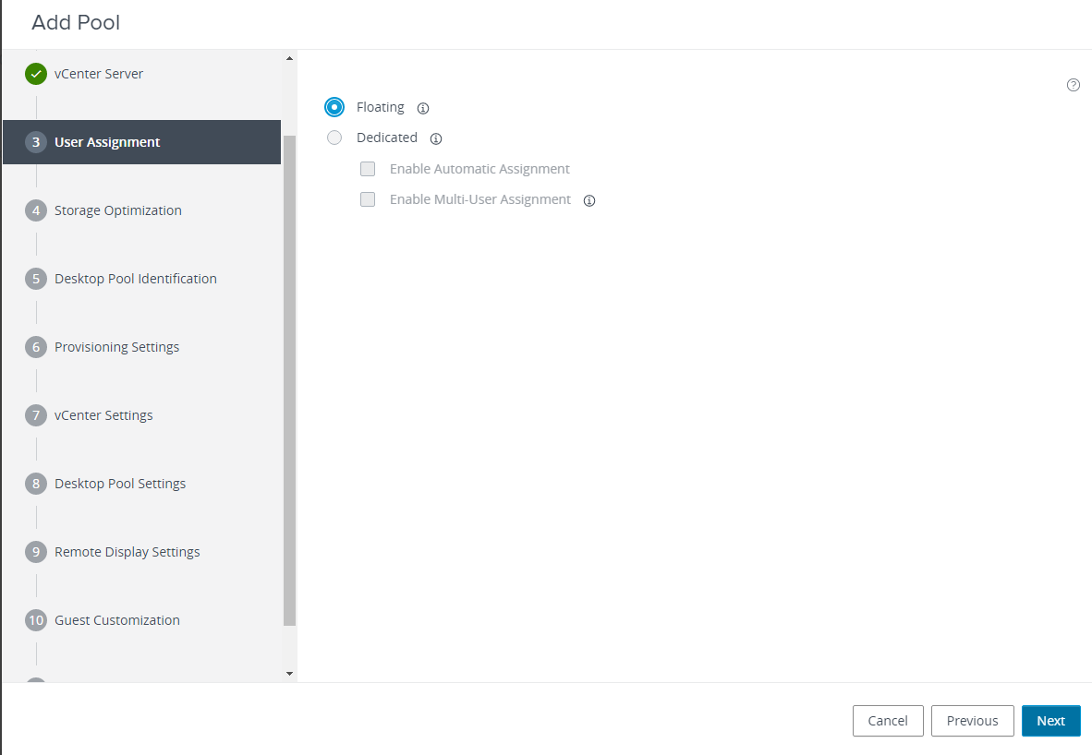

**Step 5:** Select Storage Policy Management as **Use VMware Virtual SAN**, and click **Next**:

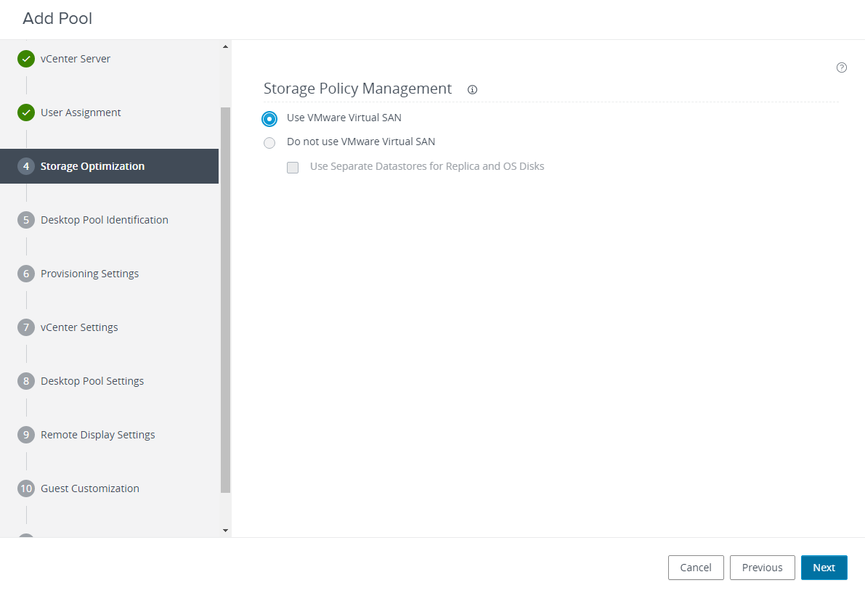

**Step 6:** Ensure the Provisioning settings as shown below, and click **Next**:

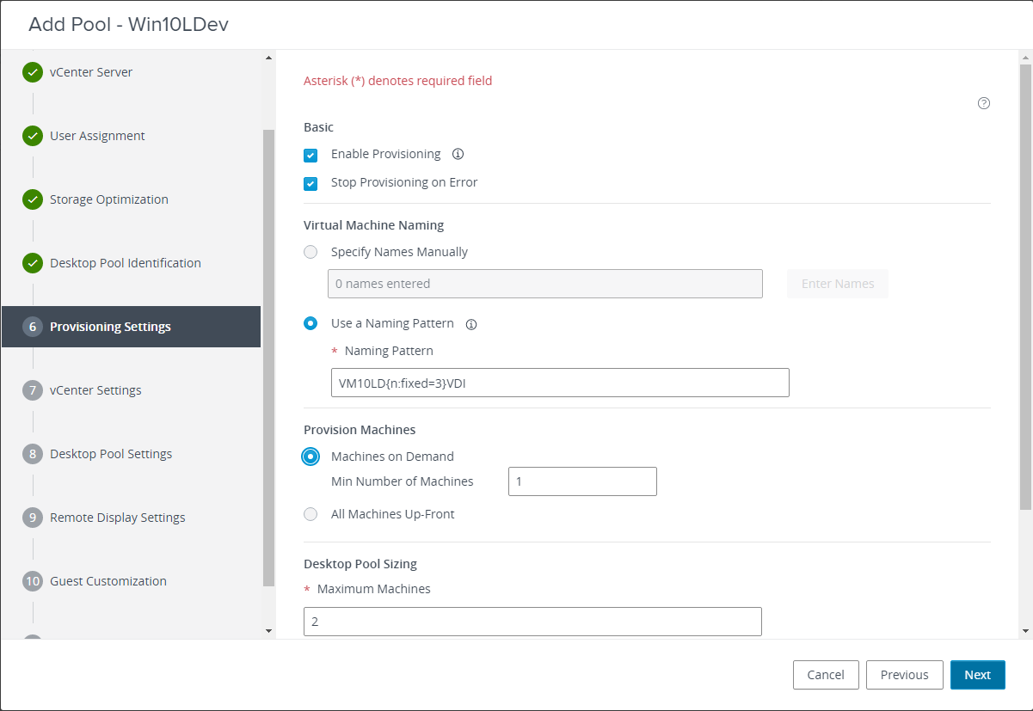

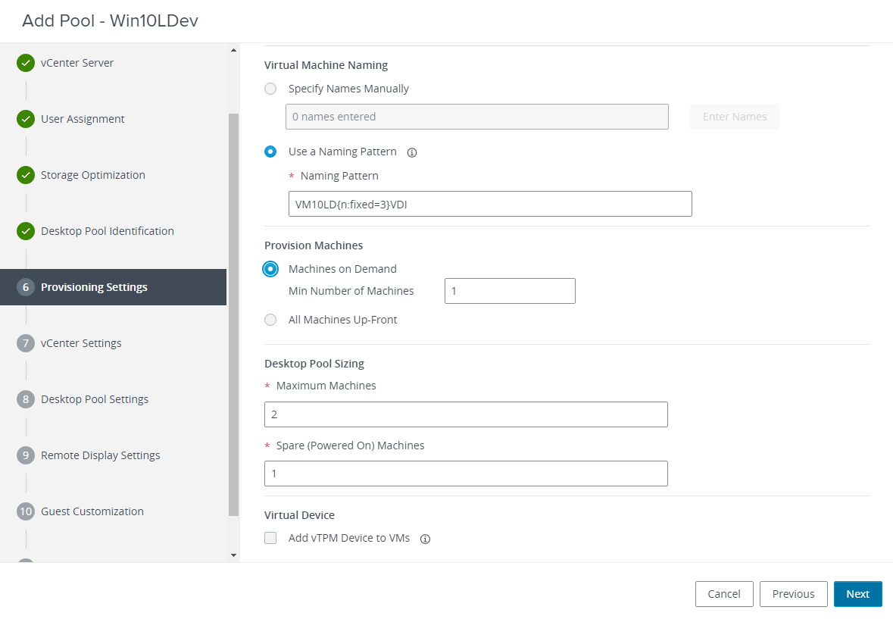

**Step 7:** Select the Network, and click **Submit**:

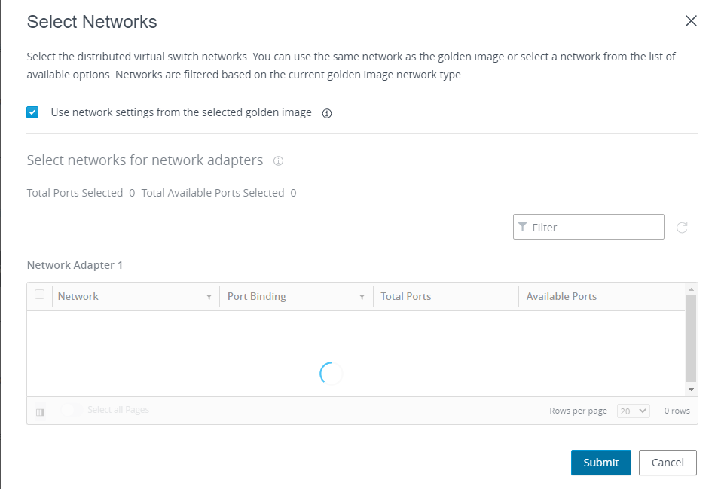

**Step 8:** Complete the mandatory fields and click **Next**:

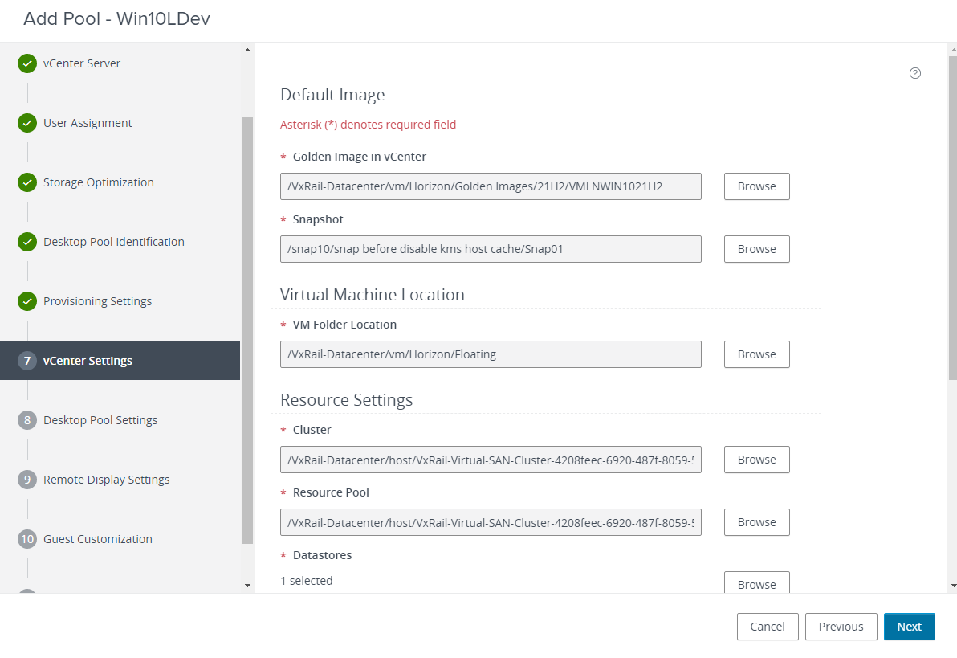

**Step 9:** Ensure the Desktop pool setting, as shown below. Click **Next**:

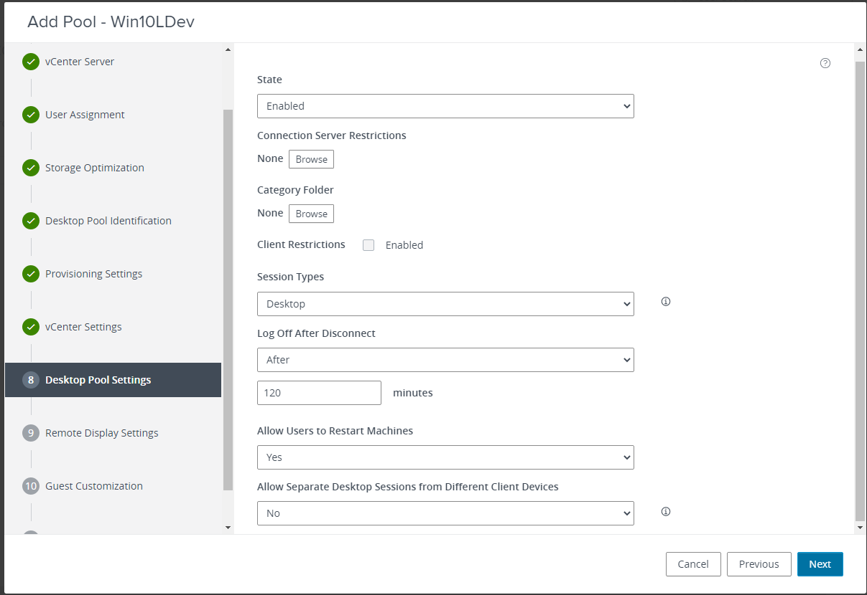

**Step 10:** Ensure the Remote Display Settings, as shown below. Click **Next**:

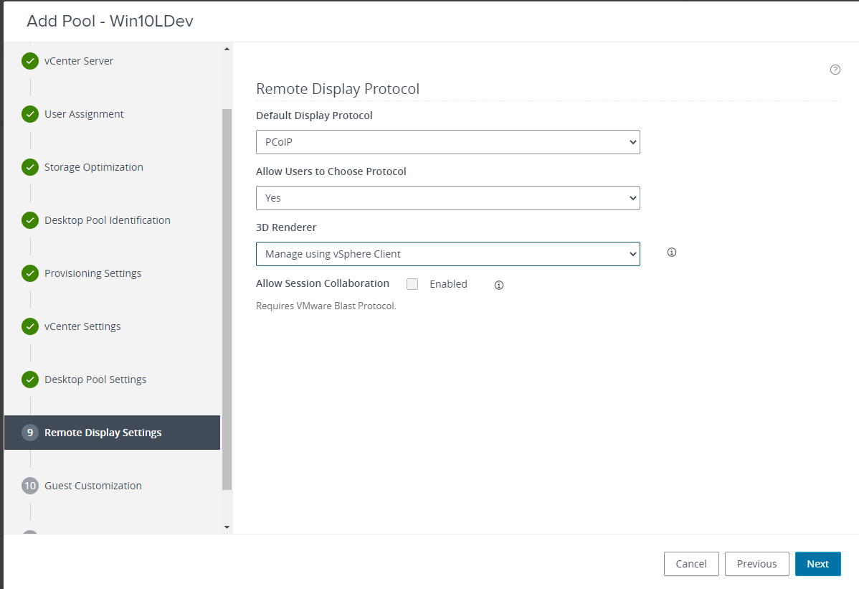

**Step 11:** Complete the mandatory fields and click **Next**:

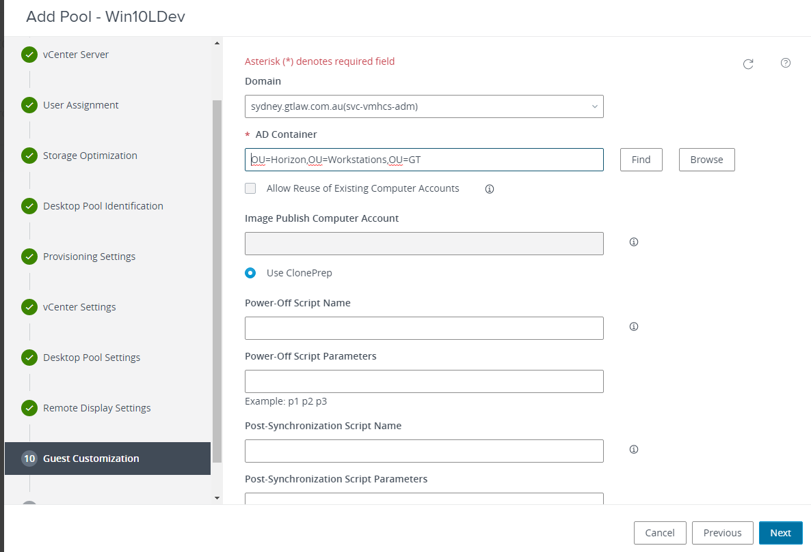

**Step 12:** Re-check the settings and click **Submit**:

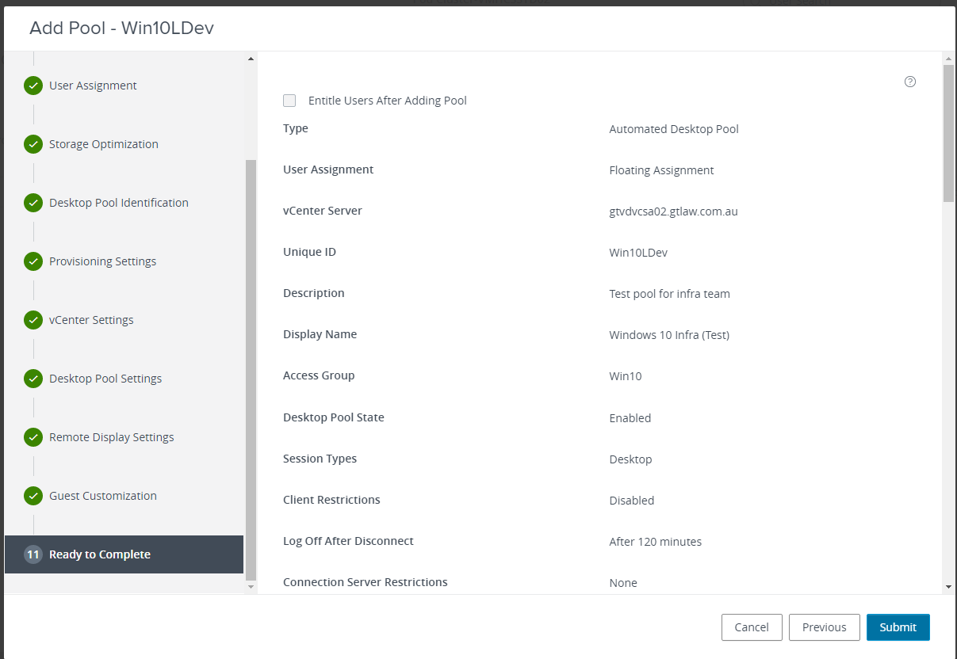

# Dynamic Environment Manager Deployment

This component manages users’ profiles on a centralized shared location. In our case, the location is: \\vmfilesharesyd1\demuserproile$

**Server:** VMITADMININFRA2.

Before proceeding with these procedures, ensure that you have created the DEM File Shares, imported the DEM GPO ADMX templates, created the GPOs for Horizon, and configured the Horizon GPOs for Dynamic Environment Manager:

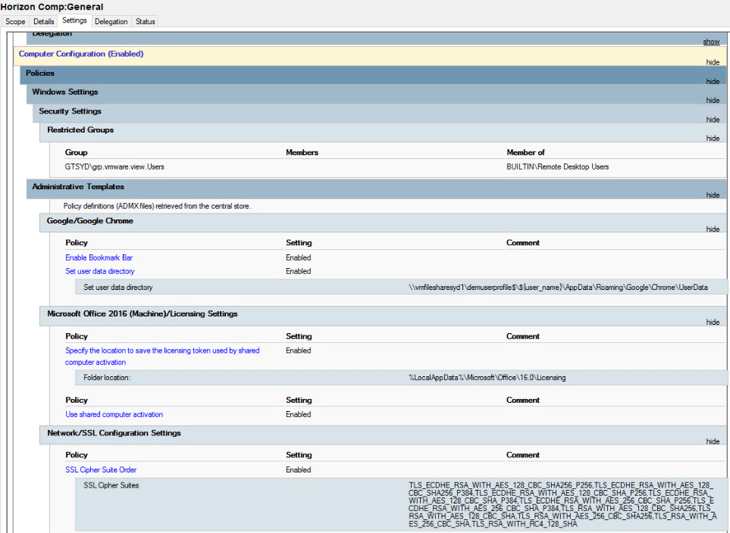

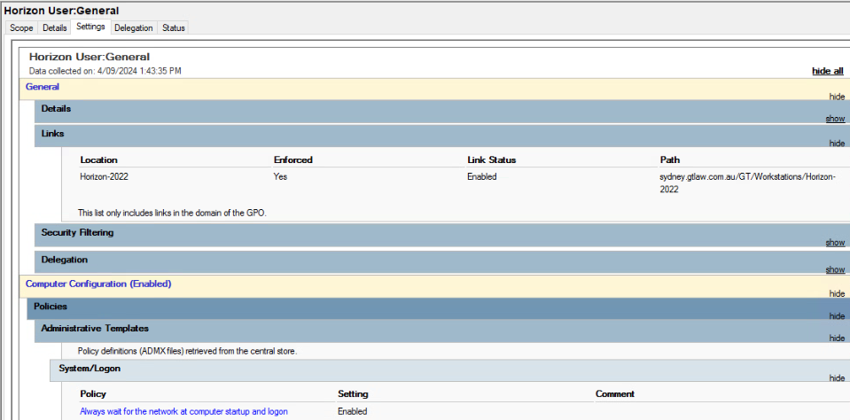

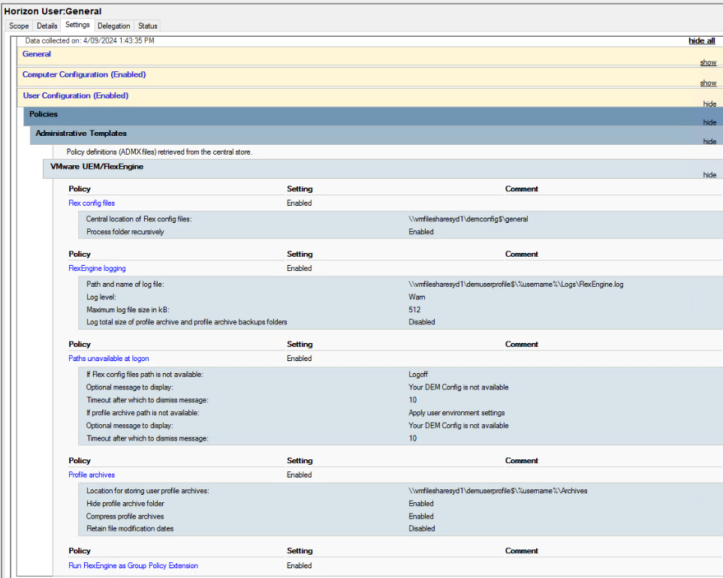



## DEM Console Installation

DEM is available in all Horizon editions. There are two editions of DEM, each with different downloads and DEM capabilities:

Horizon 8 (2406) Enterprise Edition and Horizon 7.13 Enterprise Edition are entitled to **DEM Enterprise Edition**, which has all the features.

Horizon 8 (2406) Standard Edition and Horizon 8 Advanced Edition are entitled to **DEM Standard Edition**, which is limited primarily to Personalization features.

We are using DEM Enterprise Edition:

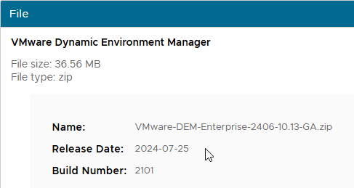

Follow these instructions to complete the DEM console installation:

**Step 1:** Check the box next to I agree, and click **Next** on the welcome page of DEM:

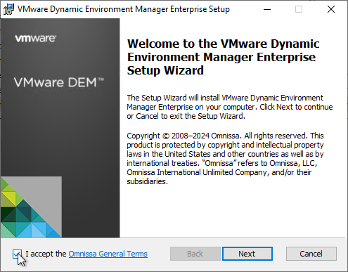

**Step 2:** Click **Next**:

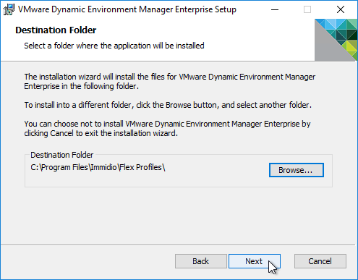

**Step 3:** Click **Custom** to modify the installation settings:

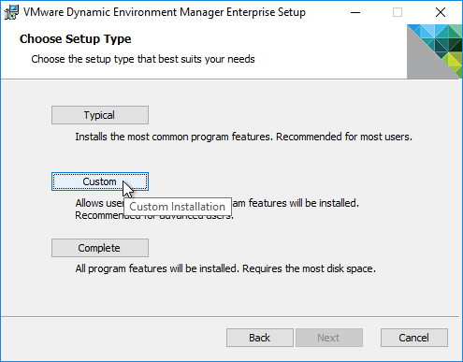

**Step 4:** Change the selections so it selects only the console, and click **Next**:

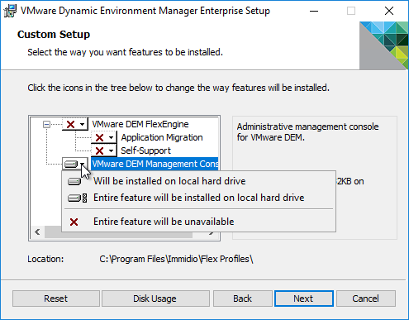

**Step 5:** Now, click **Install**:

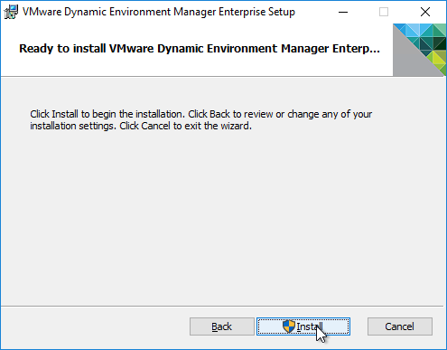

**Step 6:** After the installation, click **Finish**:

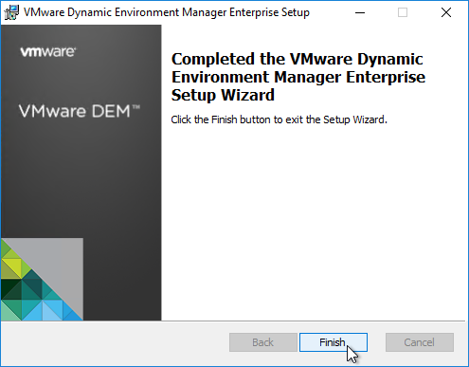

## Configuring the DEM

Follow these instructions to configure the DEM:

**Step 1:** Launch the DEM console from the start menu:

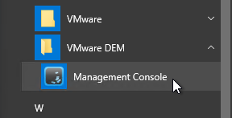

**Step 2:** Enter the path of the DEMConfig share, and click **OK**:

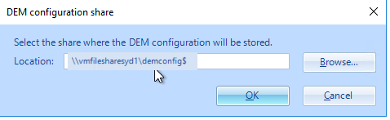

**Step 3:** Now, you will get a CEIP window, as shown below. Check the join button and click **OK**:

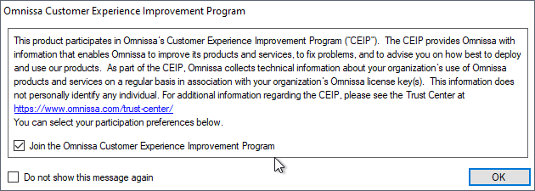

**Step 4:** Click Configure in the ribbon, and ensure these features are checked, and click **OK**:

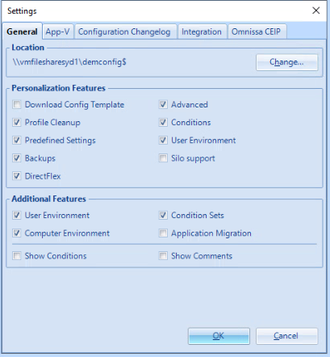

**Step 5:** Click **Easy** **Start** under the **Personalized** tab:

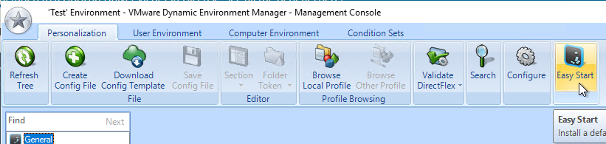

**Step 6:** Select your version of Office and click **OK**:

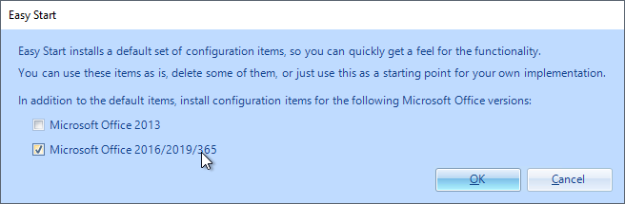

***Please Note:***Office 2016 and Office 2019 are essentially the same*.*

**Step 7:** You will get a confirmation popup window, click **OK**:

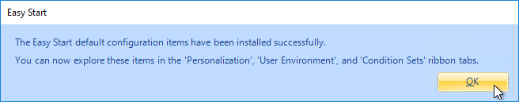

**Step 8:** Review the pre-configured settings to make sure they are acceptable.

For example, on the ribbon named **User Environment**, under **Shortcuts**, Dynamic Environment Manager might create the MSWord shortcut that says **(created by VMware UEM)**. You can either **turn off** this item or delete it:

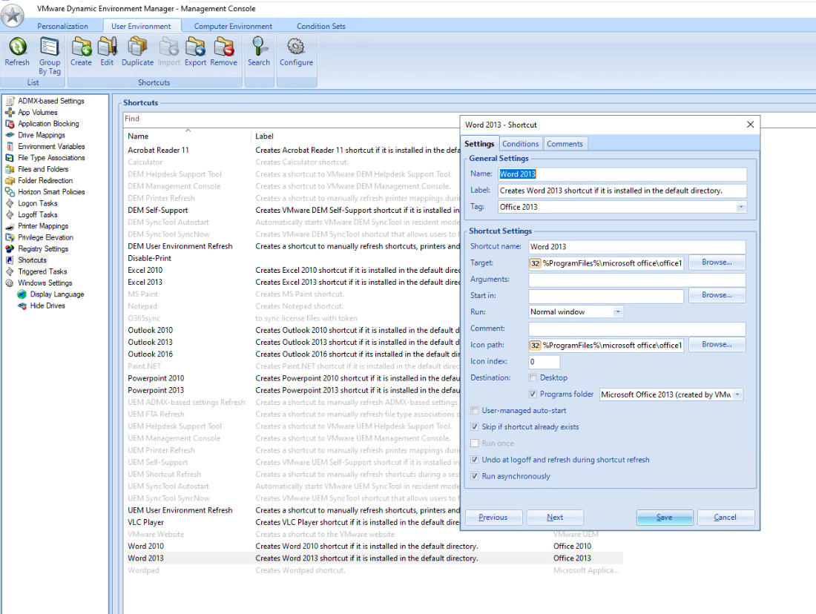

## DEM Licensing

DEM 2203 and newer moved FlexEngine Agent licensing to the DEM Configuration Share and DEM Console:

**Step 1:** Download the Production License File from the [DEM 2312 (10.12) Enterprise Edition](https://customerconnect.vmware.com/downloads/details?downloadGroup=DEM-1012-ENTERPRISE&productId=1504&rPId=115490):

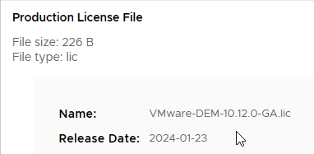

**Step 2:** In the DEM console, click the star icon on the top left, and then click **License**:

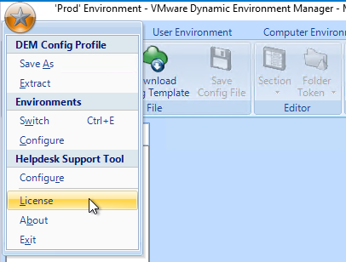

**Step 3:** Click **Manage**:

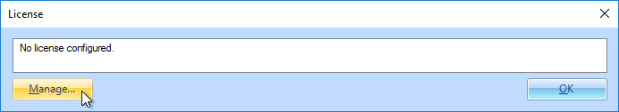

**Step 4:** Click the **License file** and select the downloaded VMware-DEM-10.13.0-GA.lic file:

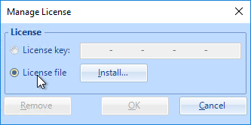

**Step 5:** Click **OK**:

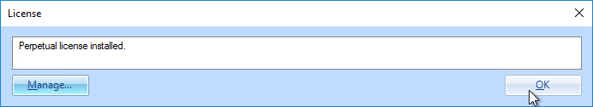

For more detailed information about DEM policy configuration, please refer to [Omnissa Dynamic Environment Manager (DEM) 2406 – Carl Stalhood](https://www.carlstalhood.com/vmware-user-environment-manager/).

# App Volume Manager Installation

Follow these instructions to install the App Vol Manager Server on both sites:

**Step 1:** Download this ISO file for App vol manager from the Omnissa portal and mount it on server vmvolappsyd02:



**Step 2:** Install the setup file with administration access:

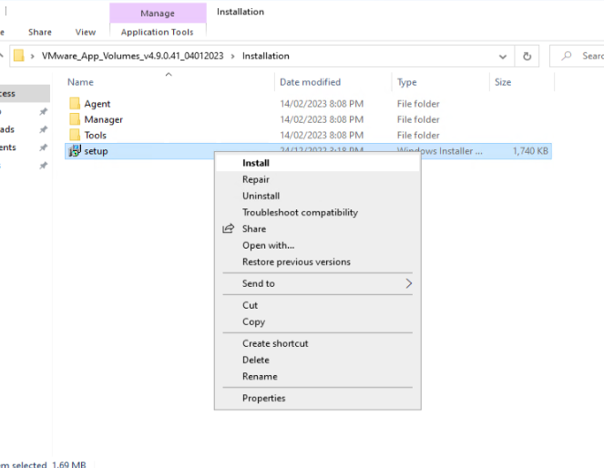

**Step 3:** Follow the step-by-step instructions below screenshots and finish the installation:

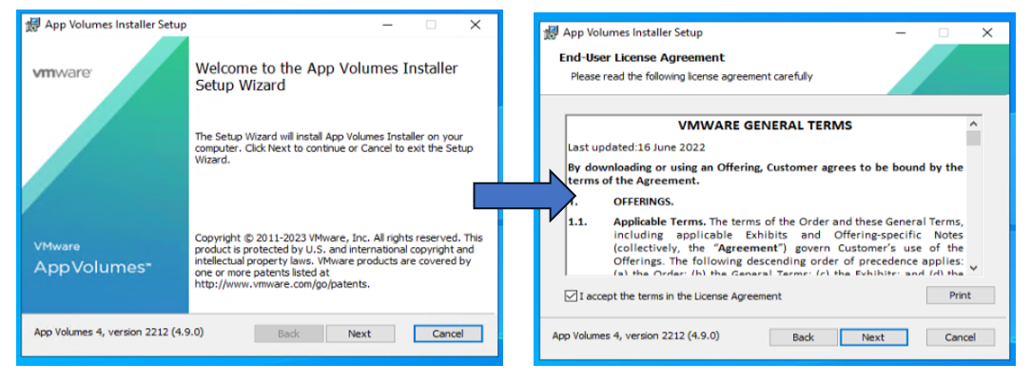

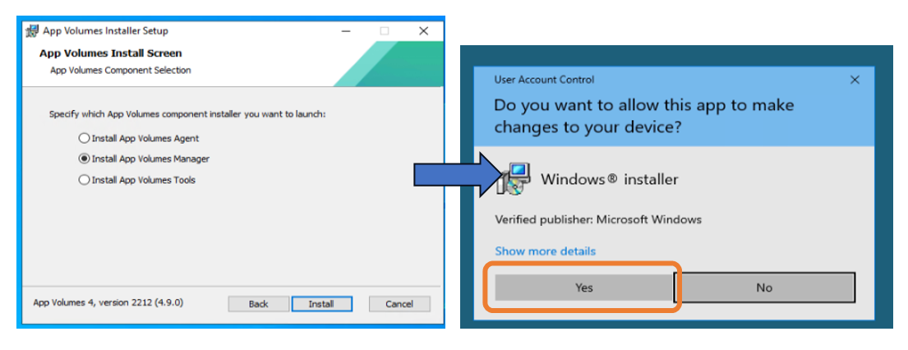

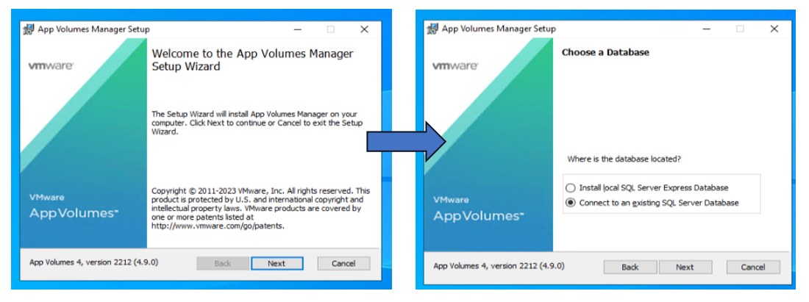

**Step 4:** Creating DB in SQL Cluster

1. Login to vmsqlsyd9c,1444 > Create DB with name VM-VolAppMgr-Event > Add DB in AG > Navigate to Always on High availability > AG01 > Availability Database > Right Click > Add Database > Before that, take the entire DB back up, then select the DB and click **Next**:

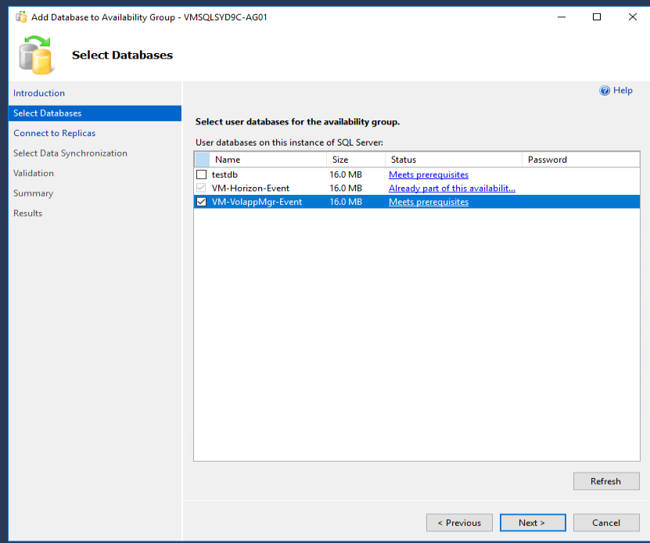

1. Connect to another node in the cluster by following the screenshot below:

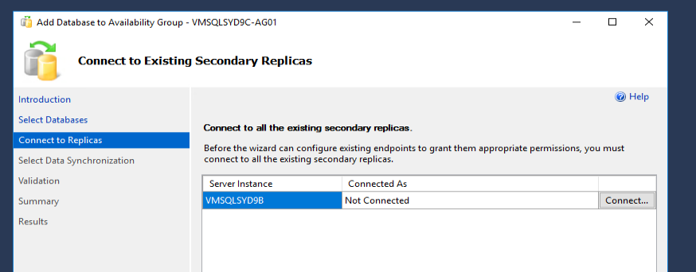

1. VolApp Manager Event DB can work with domain service accounts as well, So here, you need to authenticate with the svc-voappmgr account and follow the screenshots below:

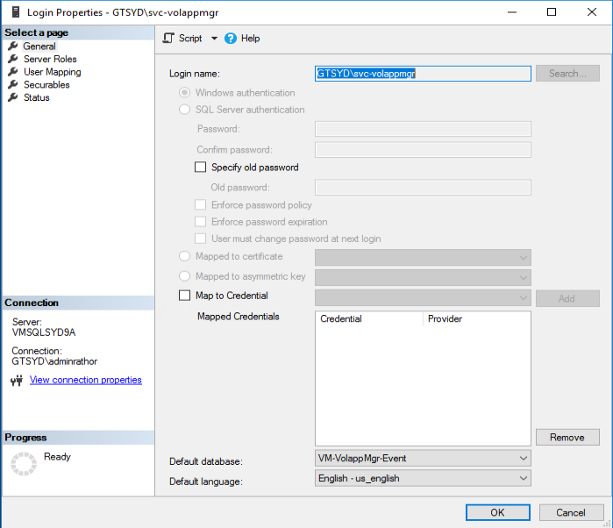

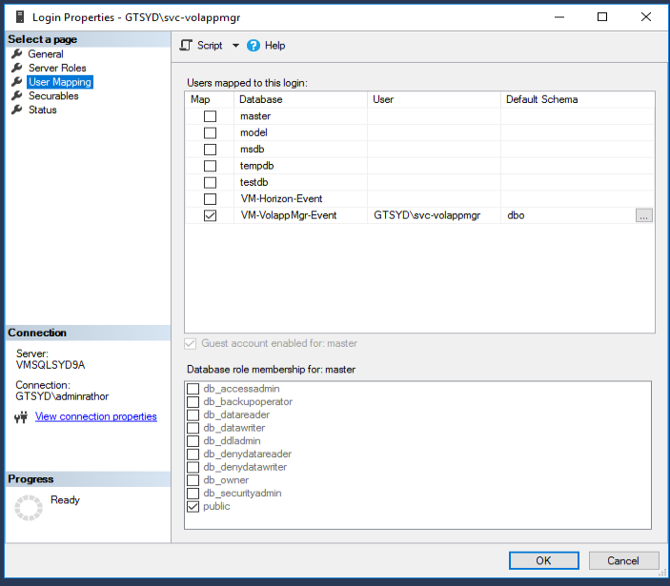

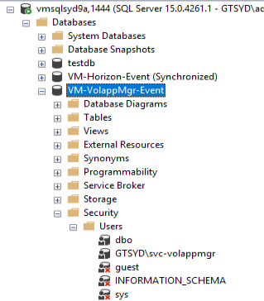

1. We will validate the Availability group listener FQDN and ensure the Vol App manager server resolves it. We need to allow SQL port from the vol app manager server to the SQL server in Ditno:

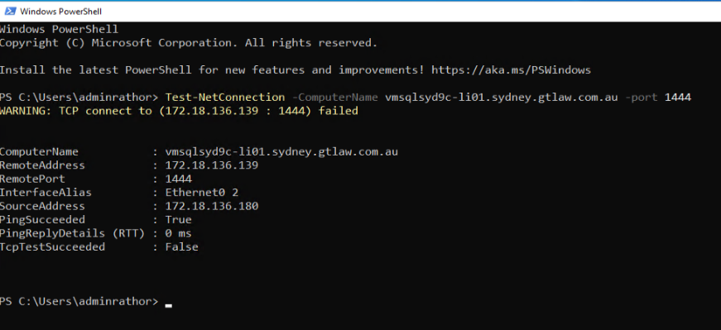

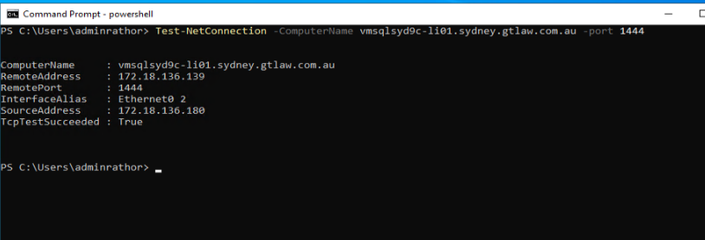

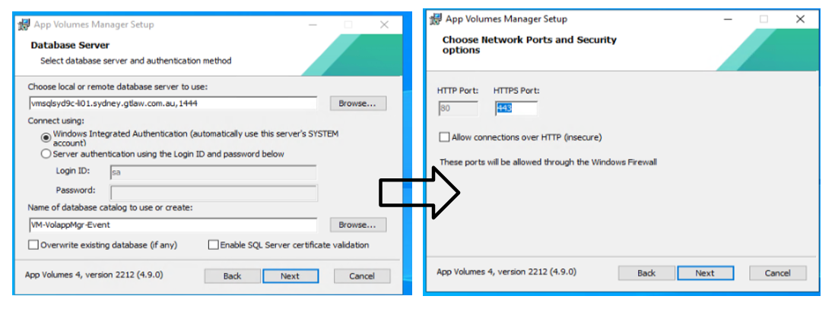

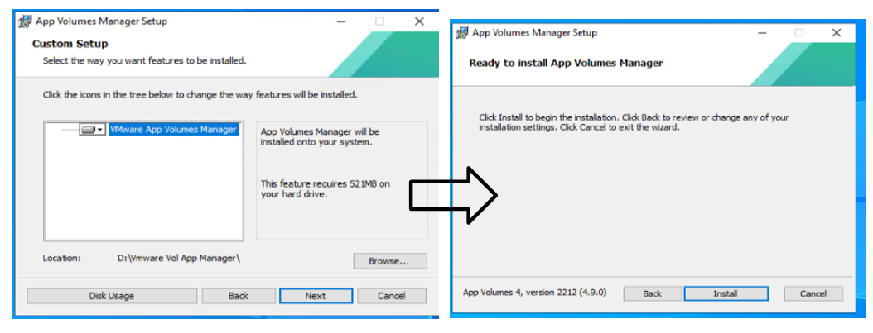

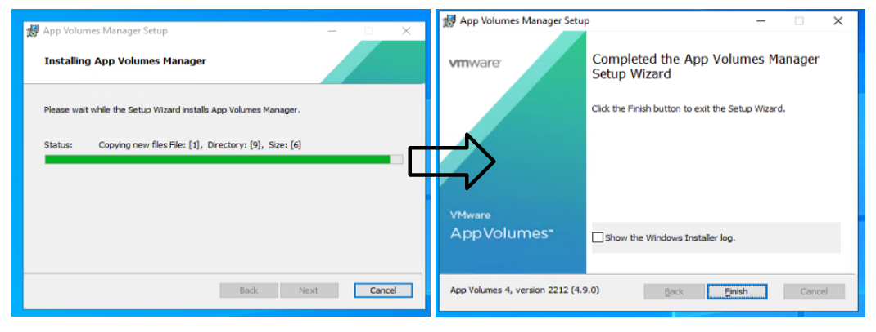

1. Post Installation, you will get this ICON on the Desktop, launch this on the server and follow the instructions to configure the App Vol Manager:

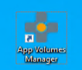

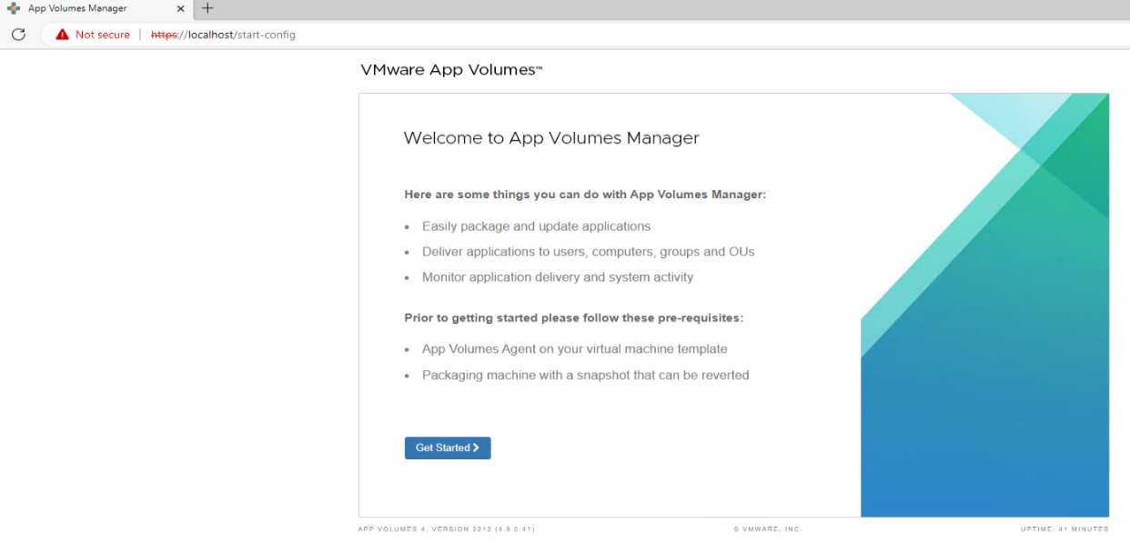



## License Installation

Follow the below step-by-step screenshots to install the license:

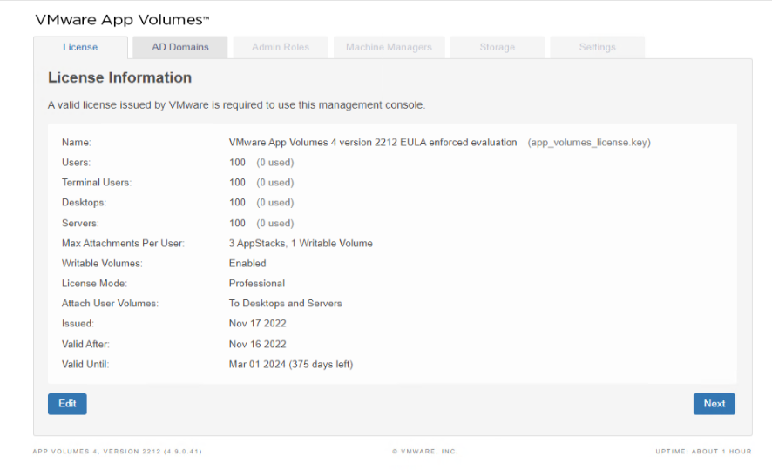

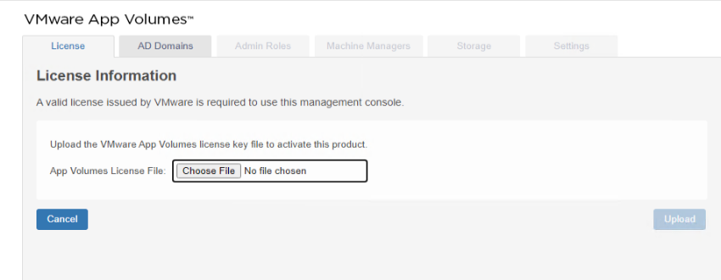

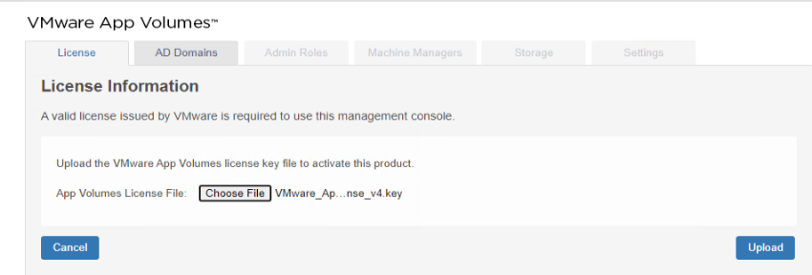

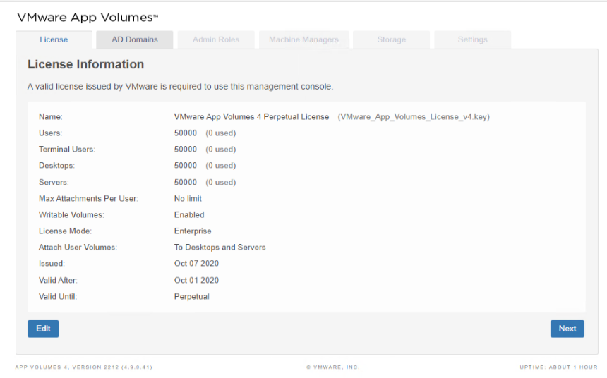

* Register it to AD Domain to authenticate the users to get the app from the app vol manager:

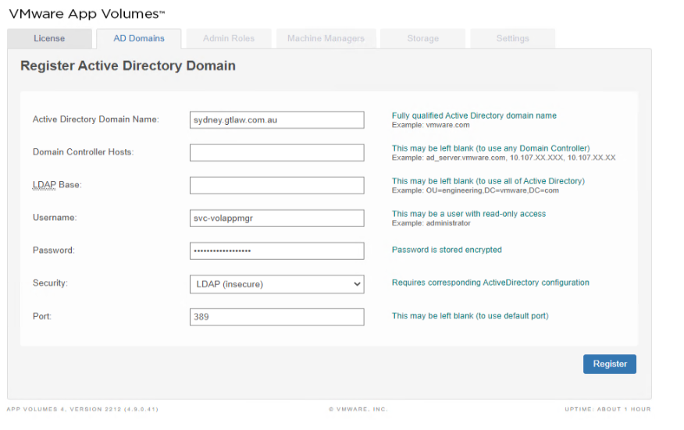



* In the Admin Role tab, provide a Full Administrator role to the group (gtsyd\grp.vmware.vCenter.Admins):

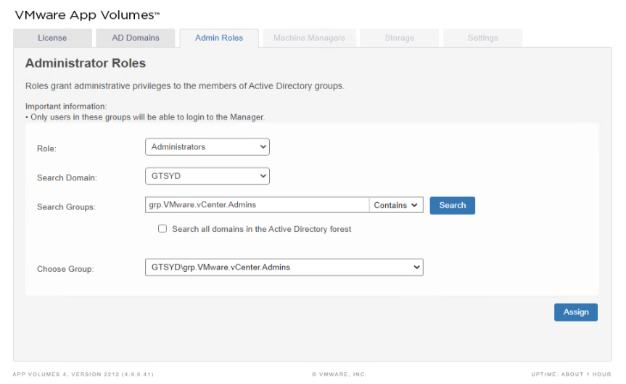

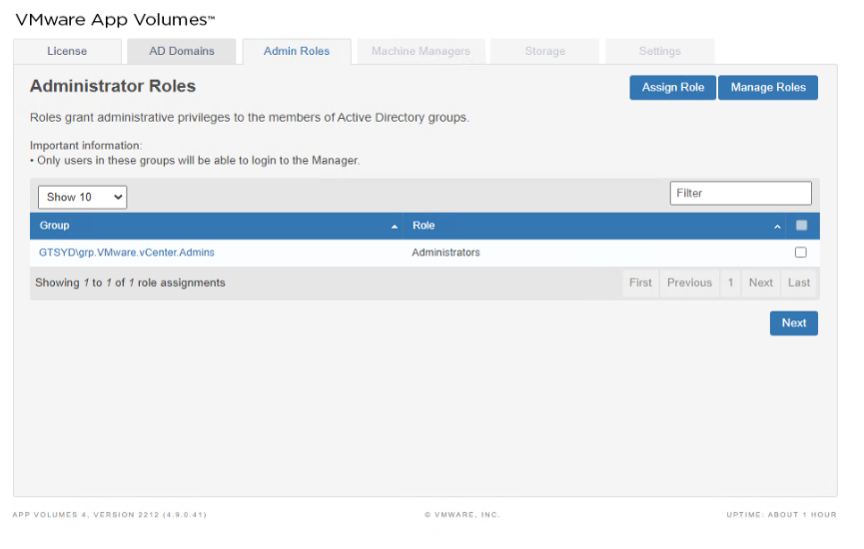

* Configuration of vCenter as a Target for Applications. Navigate to the Machine Managers tab > type vCenter Server > put vCenter FQDN > enter domain account credentials > Click on **Save**:

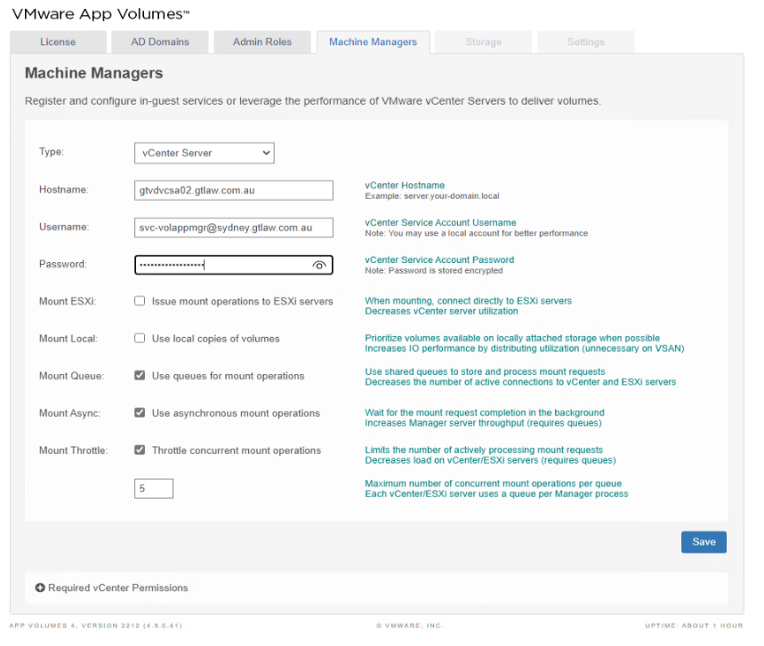

* Under the Storage tab, we need to define the vSAN datastore as shown below:

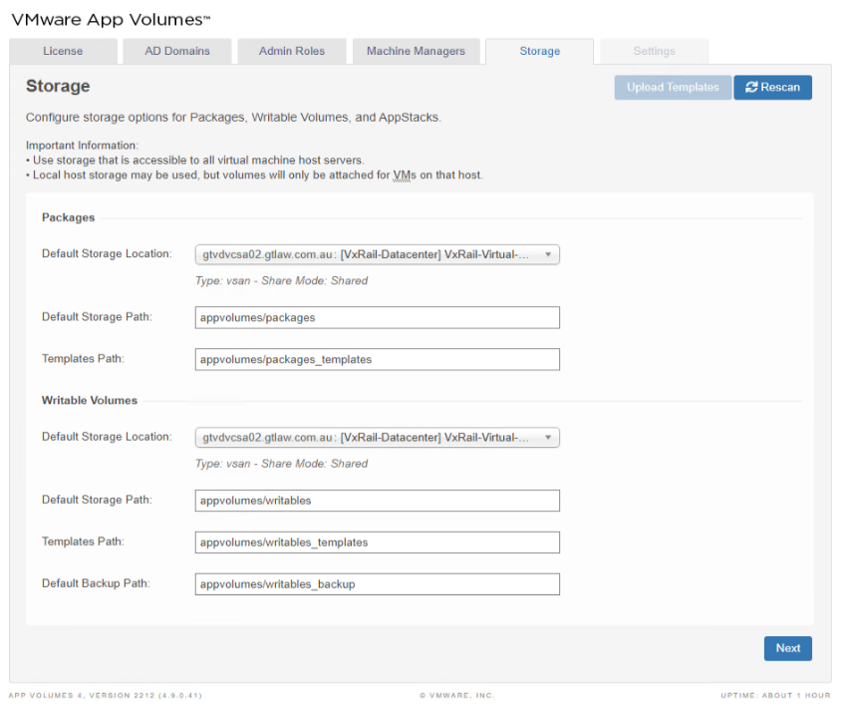

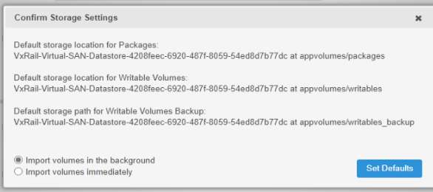

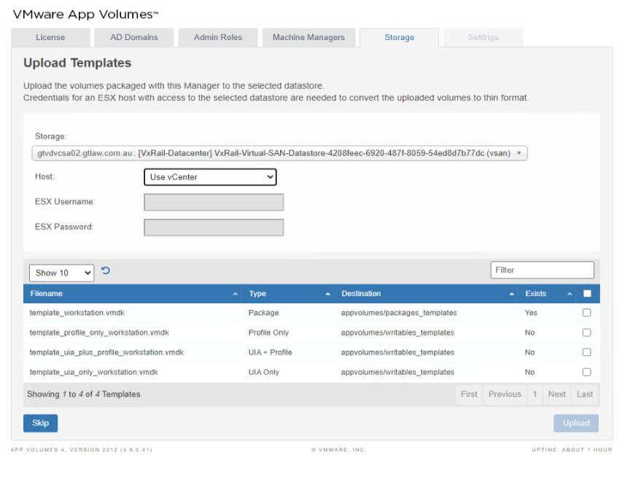

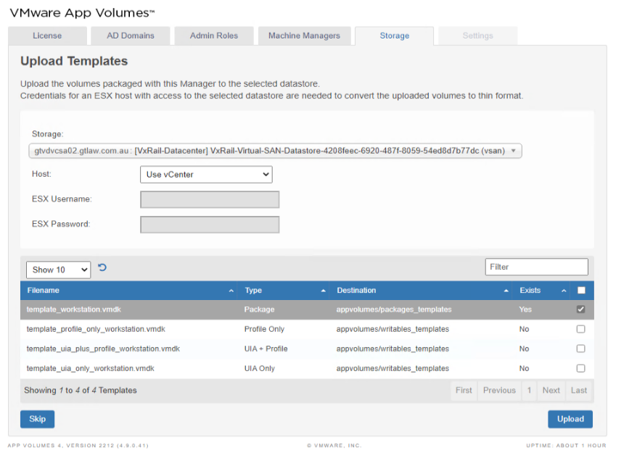

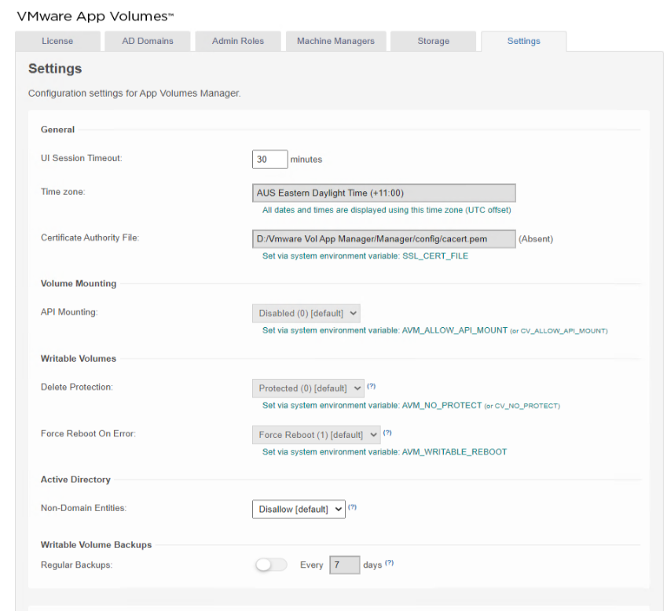

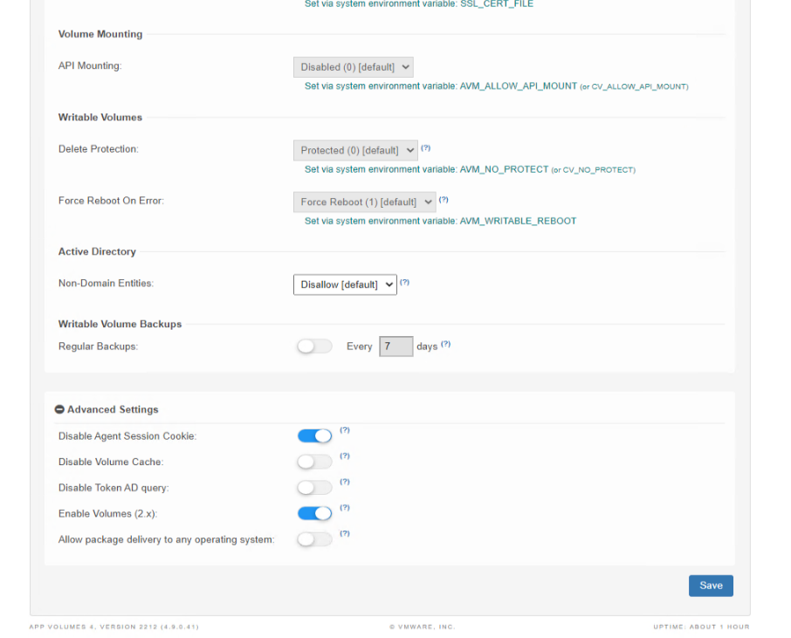

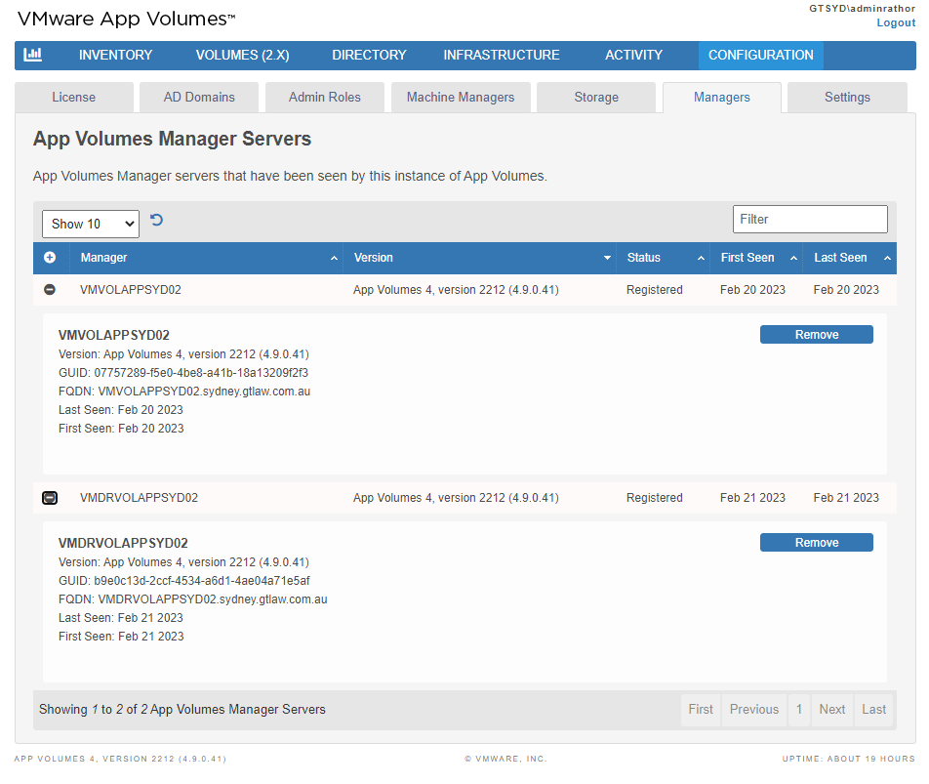

# Abbreviations/Acronyms

|  |  |  |
| --- | --- | --- |
| **Abbreviation/Acronym** | **Expansion** | **Definition** |
| VM | Virtual Machine | A virtual machine is the virtualization or emulation of a computer system. It is based on computer architectures and provides the functionality of a physical computer. |
| VDI | Virtual Desktop Infrastructure | VDI is a software technology that separates the desktop environment and associated application software from the physical client device used to access it. |
| HTML | Hypertext Markup Language | HTML is the standard markup language for documents designed for display in a web browser. |
| IPv4 | Internet Protocol version 4 | IPv4 is the first version of the Internet Protocol as a standalone specification. It is one of the core protocols of standards-based internetworking methods on the Internet and other packet-switched networks. |
| FQDN | Fully Qualified Domain Name | A fully qualified domain name, sometimes also referred to as an absolute domain name, is a domain name that specifies its exact location in the tree hierarchy of the Domain Name System. |
| SQL | Structured Query Language | Structured Query Language is a domain-specific language for managing data, especially in a relational database management system. |
| DB | Database | A database is an organized collection of data or a type of data store based on a database management system, software that interacts with end users, applications, and the database to capture and analyze the data. |
| MMC | Microsoft Management Console | MMC is a component of Microsoft Windows that provides an interface for configuring and monitoring the system for system administrators and advanced users. |
| PFX Files | Personal Information Exchange | PFX is primarily used to store and transfer cryptographic information in a single file. |
| DEM | Dynamic Environment Manager | DEM simplifies end-user profile management by providing organizations with a single, lightweight, scalable solution leveraging existing infrastructure. |
| GPO | Group Policy Object | A GPO is a virtual collection of policy settings, security permissions, and scope of management (SOM) that you can apply to users and computers in Active Directory. |
| CEIP | Customer Experience Improvement Program | CEIP is a discrete feature that collects information about your computer systems and usage patterns and transmits it back to Microsoft. Microsoft ensures that this program doesn't collect personal information. However, there isn't a way to verify what it sends out. |
| UEM | Unified Endpoint Management | UEM is a single solution that manages all device types on all platforms in all use cases. |
| ISO | International Organization for Standardization | An international standard-setting body composed of representatives from various national standards organizations. |
| AD | Active Directory | Active Directory is a directory service developed by Microsoft for Windows domain networks. Windows Server operating systems include it as a set of processes and services. |
| AG | Availability Group | A high-availability and disaster-recovery solution that provides an enterprise-level alternative to database mirroring. |
| vSAN | VMware Virtual SAN | A hyper-converged, software-defined storage (SDS) solution from VMware. |
| SVC | Service Account | A particular type of account used to run services and applications. |

# Revisions

The Infrastructure and Technical Writing teams are dedicated to continuously enhancing this document. We regularly review, test, and update it to reflect the evolving risks, systems, and business practices, ensuring its accuracy and relevance to the infrastructure team.

# Document History

|  |  |
| --- | --- |
| **Title** | VMware Horizon VDI Deployment Guide |
| **Version** | 0.1 |
| **Classification** | Internal |
| **Creation Date** | September 12, 2024 |
| **Last Review Date** | September 13, 2024 |
| **Author** | Suresh Narasimhan |
| **Custodian** | G+T Infrastructure Team |
| **Document ID** |  |

# Document Control Log

|  |  |  |  |  |
| --- | --- | --- | --- | --- |
| **Version** | **Change description** | **Authored by** | **Reviewed/Approved by** | **Date of creation** |
| 0.1 | Created the first draft | Suresh Narasimhan | Priya Bhatia | September 11, 2024 |
| 0.1 | Reviewed the first draft, made writing-related and a few info structuring corrections, updated section 7, and made it final | Priya Bhatia | Amit Rathor | September 13, 2024 |